CLASS XII CHEMISTRY (THEORY)

S.NO. | CHAPTERS | PAGE No.s
1 | SOLUTIONS | 3-11
2 | ELCTROCHEMISTRY | 12-20
3 | CHEMICAL KINETICS | 21-28
4 | d & block ELEMENTS | 29-39
5 | COORDINATION CHEMISTRY | 40-48
6 | HALOALKANES & HALOARENES | 49-57
7 | ALCOHOLS, PHENOLS & ETHERS | 58-63
8 | ALDEHYDES, KETONES & CARBOXYLIC ACIDS | 64-70
9 | AMINES | 71-75
10 | BIOMOLECULES | 76-83

CHAPTER- 1.SOLUTIONS

MCQs
Q1. Acetone and carbon disulphide form binary liquid solution showing positive deviation from Raoult’s law. The normal boiling point (Tb) of pure acetone is less than that of pure CS2.
Pick out the incorrect statement among the following-
(a) Boiling temperature of the mixture is always less than the boiling temperature of acetone
(b) Boiling temperature of Azeotropic mixture is always less than the boiling temperature of acetone
(c) When a small amount of CS2 (less volatile component) is added to an excess of acetone boiling point
of the resulting mixture increases
(d) A mixture of CS2 and CH3COCH3 can be completely separated by simple fractional distillation
Q2. An antifreeze solution is prepared from 222.6 g of ethylene glycol C2H4(OH)2 and 200 g of water.
Calculate the molality of the solution. If the density of this solution be 1.072 gmL-1, what will be the molarity of the solution?
(a) 7.20 M (b) 12.03 M (c) 9.11 M (d) 6 M
Q3. When mercuric iodide is added to the aqueous solution of potassium iodide, the:
(a) Freezing point is raised (b) Freezing point does not change
(c) Freezing point is lowered (d) Boiling point does not change
Q4. The molal elevation constant depends upon
(a) nature of solute. (b) nature of the solvent.
(c) vapour pressure of the solution.
(d) enthalpy change.
Q5. The osmotic pressure of a solution is directly proportional to
(a) the molecular concentration of the solute
(b) the absolute temperature at a given concentration
(c) the lowering of vapour pressure
(d) all the above.
Q6. Which of the following aqueous solutions containing 10 g of solute in each case, has highest boiling.pt.?
(a) NaCl solution (b) KC1 solution (c) sugar solution (d) glucose solution
Q7. Equimolar solutions in the same solvent have-
(a) Same boiling point but different freezing point
(b) Same freezing point, but different boiling point
(c) Same boiling and same freezing point
(d) Different boiling and different freezing points
Q8. The average osmotic pressure of human bloood is 7.8 bar at 37°C. What is the concentration of an aqueous solution of NaCl that could be used in blood stream?
(a) 0.15 mol L-1
(b) 0.30 mol L-1
(c) 0.60 mol L-1
(d) 0.45 mol L-1
Q9.Which of the following is incorrect for an ideal solution?
(a) ∆Hmix =0 (b) ∆Vmix = 0 (c) ∆P = Pobs – Pcalculated = 0 (d) ∆Gmix = 0
Q10.Low concentration of oxygen in the blood and tissues of people living at high altitude is due to-
(a) low temperature (b) low atmospheric pressure
(c) high atmospheric pressure (d) both low temperature and high atmospheric pressure
ANSWERS OF MCQ
[1-d; 2-c; 3-a; 4-b; 5-d; 6-a; 7-c; 8-a;; 9-d; 10-b]

******************************************

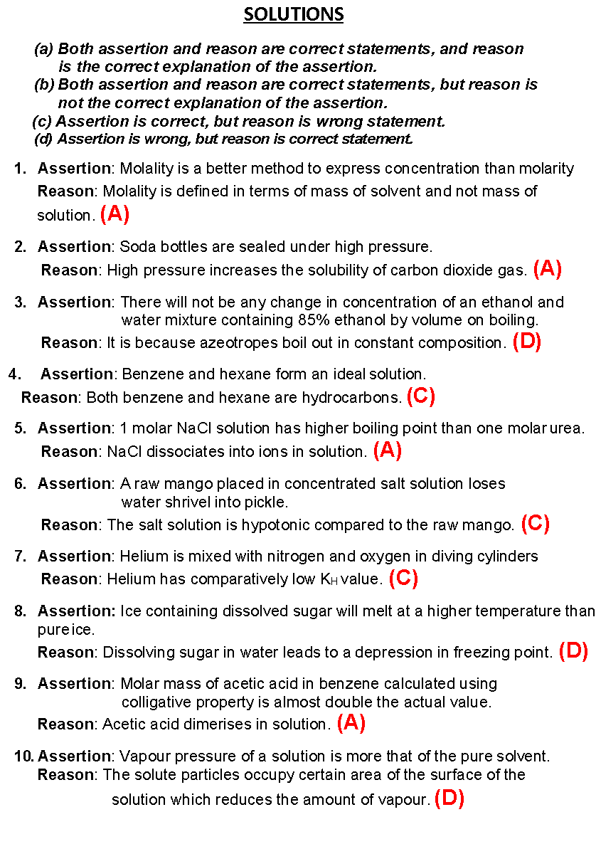
*****************************

Case based Qs
QI) Read the passage given below and answer the following questions:
Osmosis plays a significant role in the absorption of water by plant roots from the soil and its movement to different parts of the plant body. When placed in water containing more than 0.9% (mass/volume) salt, blood cells collapse due to loss of water by osmosis. In animals’ circulation of water to all parts of the body takes place due to osmosis. Osmosis helps in plant growth and germination of seeds. The phenomenon of osmosis is also useful in some industrial processes. It is employed commercially for the desalination of seawater so that it may become useful for drinking purposes. (Reverse osmosis) The Reverse Osmosis process is very popular for the purification of drinking water in households.
The osmotic pressure of a solution is the excess pressure that must be applied to a solution to prevent osmosis, i.e., to stop the passage of solvent molecules through a Semipermeable membrane into the solution. Osmotic pressure is colligative property as it depends on the number of solute molecules and not on their identity. For dilute solutions, it has been found experimentally that osmotic pressure is proportional to the molarity, C of the solution at a given temperature T. Thus: π = CRT Here π is the osmotic pressure and R is the gas constant.

Answer following questions:
(a) What is reverse osmosis ? (1)
(b) Name the membrane used in Reverse osmosis . (1)
(c)What do you expect to happen when Red blood corpuscles (RBC’s) are placed in –
(i) 1% NaCl solution (ii) 0.5% NaCl solution(2)
or
(c) Measurement of osmotic pressure method is preferred for the determination of molar mass of macromolecules .Why ?
Ans.
(a) The process of movement of solvent through a semipermeable membrane from the solution to the pure solvent by applying excess pressure on the solution side is called reverse osmosis. (1)
(b) Cellulose acetate (1)
(c) (i) RBC’s will shrink due to plasmolysis. (1)
(ii) RBC’s will swell and even burst due to haemolysis. (1)
or
because the magnitude of osmotic pressure is large even for very dilute solution and it can be measured at room temperature. (2)

QII) Read the passage given below and answer the following questions:
Henna is investigating the melting point of different salt solutions. She makes a salt solution using 10 mL of water with a known mass of NaCl salt. She puts the salt solution into a freezer and leaves it to freeze. She takes the frozen salt solution out of the freezer and measures the temperature when the frozen salt solution melts. She repeats each experiment.
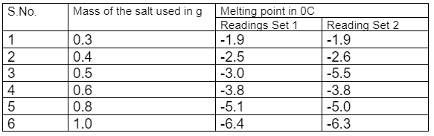

Assuming the melting point of pure water as 0⁰C, answer the following questions:
a. One temperature in the second set of results does not fit the pattern. Which temperature is that? Justify your answer. (1)
b. Why did Henna collect two sets of results? (1)
c. In place of NaCl, if Henna had used glucose, what would have been the melting point of the solution with 0.6 g glucose in it? (2)
OR
What is the predicted melting point if 1.2 g of salt is added to 10 mL of water? Justify your answer.
Ans.
a. 3rd reading for 0.5 g there has to be an increase in depression of freezing-point and therefore decrease in freezing point so also decrease in melting-point when amount of salt is increased but the trend is not followed on this case.
b. two sets of reading help to avoid error in data collection and give more objective data.
C .ΔTf (glucose) = 1 x Kf x 0.6 x 1000 / 180 x 10
ΔTf (NaCl) = 2 x Kf x 0.6 x 1000 / 58.5 x 10
3.8 = 2 x Kf x 0.6 x 1000 / 58.5 x 10
Divide equation 1 by 2
ΔTf (glucose)/ 3.8 = 58.5 / 2x 180
ΔTf (glucose) = 0.62 Freezing point or Melting point = - 0.62 ⁰C
Or
depression in freezing point is directly proportional to molality (mass of solute when the amount of solvent remains same)
0.3 g depression is 1.9 0C
0.6 g depression is 3.8 0C
1.2 g depression will be 3.8 x2 = 7.6 ⁰C

III) Read the passage given below and answer the following questions:
Colligative properties are properties of solution which depend on the number of solute particles in the solution irrespective of their nature. Colligative properties can be used to determine the molar mass of solutes in solutions. Relative lowering of vapour pressure, elevation of boiling point, depression of freezing point and osmotic pressure are important colligative properties of dilute solutions.
1. What do you mean by colligative properties? (1)
Ans. Colligative properties are properties of solution which depend on the number of solute particles in the solution irrespective of their nature
2. Relative lowering of vapour pressure of an aqueous dilute solution of glucose is 0.018. What is the mole fraction of glucose in the solution? (1)
Ans. 0.018
3.What happens to the colligative properties when ethanoic acid is treated with benzene? Give reason. (2)
Ans. Magnitude of colligative properties decreases due to association of ethanoic acid in benzene to form dimer.
OR
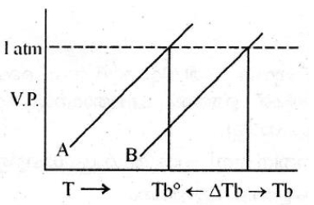
Based on the above curves Explain why the value of T_{b} is greater than that of T_{b}⁰. (2)
Ans. Addition of non-volatile solute decreases the vapour pressure of solution ,hence boiling point increases.

IV)Read the passage given below and answer the following questions:
There are a number of ways to express the relative amounts of solute and solvent in a solution. The unit you choose to use depends on how the solution is going to be used in your experiments. Common units include molarity, molality, and mole fraction. Molarity is the most common concentration unit. It is a measure of the number of moles of solute in one litre of solution. Molality is used when temperature is part of the reaction. The volume of a solution can changes when temperature changes. These changes can be ignored if the concentration is based on mass of the solvent.
1. Which of the commonly used units of concentration of solutions are temperature independent? (1)
Ans. Molality
2. Define mole fraction. (1)
Ans. It is the ratio of number of moles of a component to the toal No. of moles.
3. A mixture contains 3.2g methanol (molecular mass = 32u) and 4.6g ethanol (molecular mass = 46u). Find the mole fraction of each component. (2)
Ans.0.5 each
OR
Calculate the molarity of a solution containing 10g of NaOH in 450 ml solution. (2)
Ans.0.55M
*************************

1. | Suman took two glasses of water from a water filter. She cools one glass in a fridge and warms the other glass on a stove. Which glass of water will hold more dissolved oxygen? Explain using Henry's law. | 2
Ans | Glass kept in a fridge will contain more oxygen. Because according to Henry’s law the partial pressure of the gas in vapour phase (p) is proportional to the mole fraction of the gas (x) in the solution. p = KH x Henry constant is directly proportional to temperature. If temperature increases solubility of gas will be decreases
2 | When 2.56 g of sulphur was dissolved in 100 g of CS2, the freezing point lowered by 0.383 K. B Calculate the formula of (SX). (KF for CS2=3.83 Kkg mol-1, atomic mass of sulphur =32 g mol-1) | 2
Ans | ∆TF= KfWb x 1000/Mb x Wa 0.383=3.83 x 2.56 x 1000/Mb X 100 Mb=256 S × x =256, 32 × x =256, x = 8
3 | a) How the osmotic pressure of 5 % aqueous solution of glucose (π1) is related to that of 5 % aqueous solution of urea (π2)? b) Why do salt water fish die when they are suddenly transferred to a fresh water aquarium? | 2
Ans | a) π1 = π2 (isotonic solutions) b) Water from aquarium enters in cell causing them to expand and get ruptured.
4 | A glucose solution which boils at 101.04oC at 1 atm. What will be relative lowering of vapour pressure of an aqueous solution of urea which is equimolal to given glucose solution? (Given: Kb for water is 0.52 K kg mol-1) | 3
Ans | ΔTb = Kb m ΔTb = 101.04-100 = 1.04oCor m= 1.04 /0.52 = 2 m 2 m solution means 2 moles of solute in 1 kg of solvent. 2 m aqueous solution of urea means 2 moles of urea in 1kg of water. No. of moles of water = 1000/18 = 55.5 Relative lowering of V.P. = X2 (where X2 is mole fraction of solute) Relative lowering of V.P. = n2/n1+n2 (n2 is no. of moles of solute, n1 is no. of moles of solvent) = 2/ 2+55.5 = 2/57.5 = 0.034
5 | - While performing practicals it is directed that the bottle of liquid ammonia is to be cooled before opening seal but Suman forgot to cool it before opening. What consequence she faced ?  - Sia’s father is suffering from high blood pressure but he is advised to consume less quantity of common salt. Why?  - Out of 1M sucrose and 1M urea solution which has more osmotic pressure?  iv) A compound CuSO4.5H2O undergoes complete dissociation in water. What will be its value of Van’t Hoff factor?  - If molality of dilute solution is doubled,what will be the value of molal elevation constant(Kb)? Ans i) It is cooled to lower down the pressure of ammonia else the gas will bump out of the bottle. ii) More salt use will increase ions in the body fluid which increases blood pressure iii) Both have same osmotic pressure. iv) i=2 v) Kb dosen’t depend upon ‘m’ so remain unchanged. | 5
Ans. | - It is cooled to lower down the pressure of ammonia else the gas will bump out of the bottle.  - More salt use will increase ions in the body fluid which increases blood pressure  - Both have same osmotic pressure.  iv) i=2  v) Kb dosen’t depend upon ‘m’ so remain unchanged

*********************************

CHAPTER-2.ELECROCHEMISTRY
MCQs
- Which cell will measure the standard electrode potential of copper electrode
  - Pt (s) | H₂(g,0.1 bar) |H⁺ (aq.,1 M) || Cu²⁺aq.,1M) | Cu
  - Pt(s) | H₂(g, 1 bar) | H⁺ (aq.,1 M) || Cu²⁺(aq.,2 M) | Cu
  - Pt(s)| H₂(g, 1 bar) | H⁺ (aq.,1 M) || Cu²⁺ (aq.,1 M) | Cu
  - Pt(s) | H₂ (g, 1 bar) | H⁺ (aq.,0.1 M) || Cu²⁺ (aq.,1 M) | Cu

- Which of the statements about solutions of electrolytes is not correct
- Conductivity of solution depends upon size of ions.
- Conductivity depends upon viscosity of solution.
- Conductivity does not depend upon solvation of ions present in solution.
- Conductivity of solution increases with temperature.
- The amount of electricity required to deposit 1 mol of aluminium from a solution of AlCl₃ will be
- 0.33 Faraday
- 1 Faraday
- 3 Faraday
- 1.33 Faraday
- The positive value of the standard electrode potential for copper electrode indicates that
  - copper ions get reduced more easily than 𝐻+ ions
  - hydrogen ions can oxidise Cu
  - hydrogen gas cannot reduce copper ion
  - copper ions get oxidise more easily than 𝐻+ ions.
- The standard electrode potential for fluorine is the highest is indicating that
  - fluorine gas (𝐹2) has the maximum tendency to get reduced to fluoride ions 𝐹−
  - fluorine gas is the strongest reducing agent
  - fluoride ion is the strongest reducing agent
  - fluoride ion is the weakest oxidising agent
- The chemical equivalent mass of Cu for the reduction of Cu(II) ion to 𝐶𝑢is (atomic mass of Cu is 63.5)
  - 63.5
  - 31.7
  - 51
  - 271
- Products of electrolysis of aqueous sodium chloride solution are
  - NaOH, Cl2 and H2
  - NaOH, O2 and H2
  - NaOH, Cl2 and O2
  - sodium metal and Cl2 gas
8.If limiting molar conductivity of Ca2+ and Cl– are 119.0 and 76.3 S cm2 mol⁻¹, then the value of limiting molar conductivity of CaCl2 will be:
(a) 195.3 S cm² mol⁻¹
(b) 271.6 S cm² mol⁻¹
(c) 43.3 S cm² mol⁻¹
(d) 314.3 S cm² mol⁻¹
Ans. [1c,2c,3c,4a,5a,6b,7a, 8b]

ELECTROCHEMISTRY
- Both assertion and reason are correct statements, and reason is the correct explanation of the assertion.
- Both assertion and reason are correct statements, but reason is not the correct explanation of the assertion.
- Assertion is correct, but reason is wrong statement.
- Assertion is wrong, but reason is correct statement.

- Assertion: It is possible to make a cell with a pair of same type of half cells.
Reason: Change in concentration varies the electrode potential. (A)
- Assertion: When aqueous sodium chloride solution is electrolyzed, Oxygen gas is produced at the anode.
Reason: It is due to the overpotential for oxidation of water to oxygen. (A)
- Assertion: Molar conductivity of an electrolyte increases with decrease in concentration.
Reason: The mobility of ions decreases with increase in concentration. (A)

- Assertion: The electrode potential of standard hydrogen electrode is zero.
Reason: There is no potential difference at the electrode - solution interface in this case.
(C)
- Assertion: Reduction of 1 mole of Cu2+ ions require 2 faraday of charge.
Reason: 1 Faraday is equal to the charge of 1 mole of electrons. (A)
- Assertion: Fuel cells are pollution free.
Reason: Fuel cells use hydrogen like fuels along with oxygen gas for current production.
(B)
- Assertion: Lechlanche cell gives constant voltage throughout its life.
Reason: The overall reaction of button cell does not involve any ion in solution whose concentration can change during its life time. (D)

- Assertion: Coating iron with zinc prevents rusting.
Reason: The coating of zinc prevents moist air to come in contact with the metal. (C)
- Assertion: More negative the electrode potential greater is the power to act as oxidising agent.
Reason: As the electrode potential becomes more negative there is greater tendency to undergo oxidation. (D)
- Assertion: Secondary cells are cells which can be recharged after use.
Reason: The products are electrolysed back to the initial reactants during recharge of the cell. (A)
**************************

CASE-BASED QS.

1.Read the passage & answer the Qs
The lead-acid battery represents the oldest rechargeable battery technology. Lead acid batteries can be found in a wide variety of applications including small-scale power storage such as UPS systems, ignition power sources for automobiles, along with large, grid-scale power systems. The spongy lead act as the anode and lead dioxide as the cathode. Aqueous sulphuric acid is used as an electrolyte. The half-reactions during discharging of lead storage cells are:

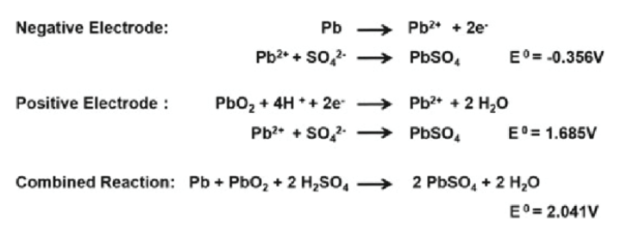
There is no safe way of disposal and these batteries end - up in landfills. Lead and sulphuric acid are extremely hazardous and pollute soil, water as well as air. Irrespective of the environmental challenges it poses, lead-acid batteries have remained an important source of energy. Designing green and sustainable battery systems as alternatives to conventional means remains relevant. Fuel cells are seen as the future source of energy. Hydrogen is considered a
green fuel. Problem with fuel cells at present is the storage of hydrogen. Currently, ammonia and methanol are being used as a source of hydrogen for fuel cell. These are obtained industrially, so add to the environmental issues.
If the problem of storage of hydrogen is overcome, is it still a “green fuel?” Despite being the most abundant element in the Universe, hydrogen does not exist on its own so needs to be extracted from the water using electrolysis or separated from carbon fossil fuels. Both of these processes require a significant amount of energy which is currently more than that gained from the hydrogen itself. In addition, this extraction typically requires the use of fossil
fuels. More research is being conducted in this field to solve these problems. Despite the problem of no-good means to extract Hydrogen, it is a uniquely abundant and renewable source of energy, perfect for our future zero-carbon needs.
Answer the following questions:
(a) How many coulombs have been transferred from anode to cathode in order to consume one mole of sulphuric acid during the discharging of lead storage cell? (1)
(b) How much work can be extracted by using lead storage cell if each cell delivers about (1)
2.0 V of voltage? (1 F = 96500 C)
(c) Do you agree with the statement – “Hydrogen is a green fuel.” Give your comments for and against this statement and justify your views. (2)
OR
Imagine you are a member of an agency funding scientific research. Which of the following projects will you fund and why?
(i) safe recycling of lead batteries
(ii) extraction of hydrogen
Ans.
(a) 2mol e– (or 2F) have been transferred from anode to cathode to consume 2 mol of H 2SO4
therefore, one mole H 2SO4 requires one faraday of electricity or 96500 coulombs. (1)
(b) w_{max} = – nFE° = – 2× 96500 × 2.0 = 386000 J of work can be extracted using lead storage cell when
the cell is in use. (1)
(c) Both yes and no should be accepted as correct answers depending upon what explanation is provided.
Yes, Hydrogen is a fuel that on combustion gives water as a byproduct. There are no carbon emissions and no pollutions caused.
However, at present the means to obtain hydrogen are electrolysis of water which use electricity obtained from fossil fuels and increase carbon emissions.
Inspite of the problems faced today in the extraction of hydrogen, we cannot disagree on the fact that hydrogen is a clean source of energy. Further research can help in finding solutions and greens ways like using solar energy for extraction of hydrogen. (2)
No. It is true that Hydrogen is a fuel that on combustion gives water as a byproduct. There are no carbon emissions and no pollutions caused.
However, at present the means to obtain hydrogen are electrolysis of water which use electricity obtained from fossil fuels and increase carbon emissions.
Hydrogen is no doubt a green fuel, but the process of extraction is not green as of today. At present, looking at the process of extraction, hydrogen is not a green fuel. (2)
OR
Both answers will be treated as correct
(i) Lead batteries are currently the most important and widely used batteries. These are rechargeable. The problem is waste management which needs research and awareness. Currently, these are being thrown into landfills and there is no safe method of disposal or recycling. Research into safer method of disposal will reduce the pollution and health hazards caused to a great extent.
( 1 mark for importance, 1 for need for the research)
(ii) Fuel cell is a clean source of energy. Hydrogen undergoes combustion to produce water. The need of the hour is green fuel and hydrogen is a clean fuel. The current problem is obtaining hydrogen. Research that goes into this area will help solve the problem of pollution and will be a sustainable solution.
(1 mark for importance, 1 for need for the research)

2. Read the passage below and answer the following questions:

A process in which on passing electricity electrolyte split into ions and ions are deposited at opposite electrode is called electrolysis. Faraday’s First law of electrolysis: The amount of substance deposited or liberated during electrolysis is directly proportional to the quantity of electricity passed through the solution. Faraday's Second law of electrolysis When same amount of current is passed through different electrolytes which are connected in series, the amount of substance deposited/ liberated from different electrolytes is directly proportional to their equivalent weight.
1. Define electrochemical equivalent (Z). (1)
2. How much electricity in terms of Faraday is required to produce 20⋅0 g of Ca from molten CaCl₂? (Given At. mass Ca=40g) (1)
OR
2. How much electricity in terms of Faraday is required to produce 40⋅0 g of Al from molten Al₂O₃?
(Given At. mass Al=27g)
3. A solution of Ni (NO₃)₂ is electrolyzed between platinum electrodes using a current of 5 amperes for 20 minutes. What mass of Ni is deposited at the cathode? (Given At. Mass Ni=58.5g) (2)

1. Electrochemical equivalent is defined as the amount of substance deposited or liberated by the passage of 1 ampere of current for one second i.e. one coulomb charge. (1)
2. Ca²⁺ + 2e − → Ca To produce 40 g Ca, electricity needed = 2F ∴
To produce 20 g Ca, electricity needed = 40/ 2 × 20 = 1F (1)
OR
2. Al³⁺ + 3e − → Al To produce 27 g Ca, electricity needed = 3F
∴ To produce 40 g Al, electricity needed = 27/ 3 × 40 = 4⋅44F
3. Quantity of electricity passed (Q) = Current in amperes × time in second
= 5 × 20 × 60 = 6000 C
Ni⁺² + 2e − → Ni i.e. 2 × 96487 C of electricity deposited Ni = 58⋅5 g
∴ 6000 C of electricity deposit Ni =(58.5/2 × 96487) × 6000 = 1⋅82 g (2)
OR
3. Quantity of electricity (Q) = Current × time
= 1⋅5 × 10 × 60 = 900 C
According to the reaction: Cu⁺² + 2e − → Cu
We required 2 F or 2 × 96487 C of electricity to deposit 1 mol or 63 g of Cu
∴ 900 C electricity will deposit = (63/2 × 96500) × 900
= 0⋅2938 g of Cu at the cathode. (2)
******************************

1. | Three iron sheets have been coated separately with three metals 𝐴, 𝐵 and 𝐶 whose standard electrode potentials are given below. Identify in which rusting will takes place faster when coating is damaged. E 0 for Metals A, B, C and Iron are − 0.46V, −0.66V, −0.20V and − 0.44V respectively. | 2
Ans | As iron (−0.44𝑉) has lower standard reduction potential than 𝐶 (−0.20𝑉) only and therefore when coating is broken, rusting will take place faster.
2 | Why on dilution the ⋀m of CH3COOH increases drastically while that of CH3COONa increases gradually? | 2
Ans | CH3COOH is a weak electrolyte, the number of ions increase on dilution due to an increase in degree of dissociation.
3 | Calculate the cell emf and ΔG ∘ for the cell reaction at 25∘𝐶 for the cell: Zn s Zn2+ 0.0004M ∥ Cd2+ 0.2M Cd s At 25∘C: EZn2+/Zn ∘ = −0.763V; ECd2+/Cd ∘ = −0.403V; F = 96500Cmol−1 ; R = 8.314JK −1mol−1 .  (b) If 𝐸 ∘ for copper electrode copper ions is 0.34𝑉 ? How does emf for copper electrode change when concentration of Cu2+ ions is decreased? how will you calculate its emf value when the solution in contact with it is 0.1𝑀 in the solution | 3
Ans | 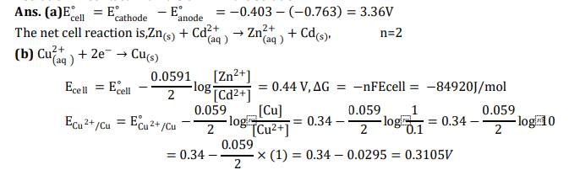
4. | The electrochemical cell given alongside converts the chemical energy released during the redox reaction to electrical energy: Zn s + Cu2+ aq ⟶ Zn2+ aq + Cu s It gives an electrical potential of 1.1V when concentration Zn2+ and Cu2+ ions is unity. State the direction of flow of current and also specify whether zinc and copper are deposited or dissolved at their respective electrodes when: (i) an external opposite potential of less than 1.1 V is applied. (ii) an external potential of 1.1𝑉 is applied. (iii) an external potential of greater than 1.1𝑉 is applied. | 3
Ans | Ans. (i) Reaction continues to take place. Electrons flow from Zn electrode to copper electrode, current flows from Cu to Zn. Zn dissolves and copper deposits at their respective electrodes. (ii) The reaction stops and no current flows. (iii) Reaction takes place in opposite directions. Electrons flow from copper electrode to zinc electrode, current flows from Zn to𝐶𝑢. Cell functions as an electrolytic cell
5 | (i) State two advantages of H2—O2 fuel cell over ordinary cell. (ii) Silver is electrodeposited on a metallic vessel of total surface area 500 cm2 by passing a current of 0.5 A for two hours. Calculate the thickness of silver deposited. [Given: Density of silver = 10.5 g cm–3, Atomic mass of silver = 108 amu, F = 96,500 C mol–1] Ans. (i) | 5
Ans | Pollution free, 75% efficiency, continuous source of energy. (ii) w =ZIt = 4.029g, V=m/d = 0.3837 cm3, Thickness of Ag deposited is x, V= A. x = 7.67x10-4cm

CHAPTER-3.CHEMICAL KINETICS

MCQs
1. A reaction is first order with respect to reactant A. What will be the initial rate, if concentration of reactant is reduced by half?
(a) Halved
(b) doubled
(c) tripled
(d) not changed
2. What is the ratio of the rate of decomposition of N2O5 to the rate of formation of NO2?
2N2O5(g) ------------> 4NO2(g) + O2(g)
(a) 1:4
(b) 2;1
(c) 4:1
(d) 1:2
3. In the first order reaction, the concentration of the reactant is reduced to 1/4th in 60 minutes. What will be its half-life?
(a) 120 min
(b) 40 min
(c) 30 min
(d) 25 min
4. Which of the following reaction ends in infinite time?
(a) Zero order
(b) First order
(c) Second order
(d) Third order
5. The rate constant of a zero-order reaction is-
(a) Directly proportional to initial concentration
(b) Doesn’t depend on concentration
(c) Inversely proportional to initial concentration
(d) Can’t say
6. The first order reaction takes 80 minutes to complete 99.9%. What will be its half-life?
(a) 8 min
(b) 16 min
(c) 24 min
(d) 32 min
7. A catalyst increases the reaction rate by:
(a) decreasing enthalpy
(b) increasing internal energy
(c) decreasing activation enthalpy
(d) increasing activation enthalpy
8. Chemical kinetics is the study to find out:
(a) The feasibility of a chemical reaction
(b) Speed of a reaction
(c) Extent to which a reaction will proceed
(d) All of the above
9. The rate of a reaction:
(a) Increases as the reaction proceeds
(b) Decreases as the reaction proceeds
(c) Remains the same as the reaction proceeds
(d) May increase or decrease as the reaction proceeds
10. Which of the following influences the reaction rate performed in a solution?
(a) Temperature
(b) Activation energy
(c) Catalyst
(d) All of the above
ANSWERS – 1. (a) 2. (d), 3. (c), 4.(b), 5.(a), 6.(a), 7.(c), 8.(d), 9.(d), 10.(d)
******************************

CHAPTER-3.CHEMICAL KINETICS
A) Both assertion and reason are correct statements, and reason is the correct explanation of the assertion.
B )Both assertion and reason are correct statements, but reason is not the correct explanation of the assertion.
C)Assertion is correct, but reason is wrong statement.
D)Assertion is wrong, but reason is correct statement.

- Assertion: Hydrolysis of methyl ethanoate is a pseudo first order reaction.
Reason: Water is present in large excess and therefore its concentration remained constant throughout the reaction. (A)
- Assertion: Order of a reaction can be zero.
Reason: In the case of heterogeneous catalysis, the reaction becomes independent of concentration at high concentration of the reaction. (A)
- Assertion: The slowest elementary step in a complex reaction decides the rate of the reaction.
Reason: The slowest elementary step always has the smallest molecularity. (C)
- Assertion: A catalyst increases the rate of a reaction.
Reason: The catalyst increases the activation energy which in turn increases the rate of the reaction. (C)
- Assertion: Activation complex for the forward reaction will have lower energy than that for the backward reaction in an exothermic reaction.
Reason: Reactants have greater energy than products for an exothermic reaction. (D)
- Assertion: Increase in temperature increases rate of reaction.
Reason: More colliding molecules will have energy greater than threshold energy. (A)
- Assertion: Unit of rate constant is independent of order of reaction.
Reason: The power of concentration terms in the rate equation keep changing with change in order. (D)
- Assertion: Increase in concentration of reactant will not change the rate for a zero-order reaction.
Reason: Rate constant for a zero-order reaction is a constant for a particular initial concentration. (B)
9.Assertion: The half-life of a reaction is independent of initial concentration for a first order reaction.
Reason: The integrated rate law for a first order reaction is independent of initial concentration. (C)
10.Assertion: Half-life of a reaction can be used to predict order of a reaction.
Reason: The relationship between half-life and initial concentration of the reactant is dependent on order. (A)
    - *******************************

PASSAGE-BASED
Passage-1
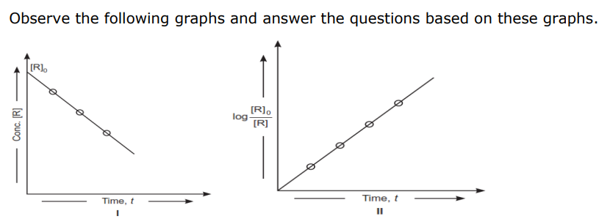
(a) What is order of reaction shown in graph I?(1)
Ans :- Zero order reaction.
(b) What is slope in graph II? (1)
Ans: k /2.303where ‘k’ is rate constant.
(c) How does t1/2 vary with initial concentration in zero order reaction. (1)
Ans: t1/2 is directly proportional to initial concentration.
(d) If t1/2 of first order reaction is 40 minutes, what will be t99.9% for first
order reaction? (1)
Ans: t99.9% = 10 t1/2 = 10 × 40 = 400 minutes
OR
What is t1/2 of zero order reaction in terms of ‘k’?
Ans: t1/2 = [R]0 /2k for zero order reaction.
Passage-2
The rate of a chemical reaction is expressed either in terms of decrease in the
concentration of reactant per unit time or increase in the concentration of a
product per unit time. rate of reaction depends upon the nature of reactants,
concentration of reactants, temperature, presence of catalyst, surface area
of reactants and presence of light. Rate of reaction is directly related to the
concentration of reactant. Rate law states that the rate of reaction depends
upon the concentration of terms on which the rate of reaction actually
depends, as observed experimentally. The sum of powers of the concentration
of the reactants in the rate law expression is called order of reaction while the
number of reacting species taking part in an elementary reaction which must
collide simultaneously in order to bring about a chemical reaction is called
molecularity of the reaction.
(a) If the rate of a reaction is expressed by, rate = K [A]² [B], the order
of reaction will be (1)
Ans: 3
(b) The unit of rate constant for the reaction which has
rate =K[H2] [NO]2 (1)
Ans: mol⁻² L² s ⁻¹
(c) For a reaction x + y → z, rate α |X|. What is (i) molecularity and (ii) order
of reaction? (2)
Ans: (i) 2, (ii) 1
(d) The number of molecules of the reactants taking part in a single step
of the reaction is indicative of __________
Ans:- molecularity of a reaction
Passage-3
The half-life of a reaction is the time required for the concentration of reactant
to decrease by half, i.e., [A]t = [A]/2
For first order reaction, t1/2 = 0.693/k
this means t1/2 is independent of initial concentration.

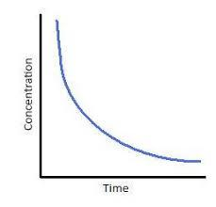

Figure shows that typical variation of concentration of reactant exhibiting first order kinetics. It may be noted that though the major portion of the first order kinetics may be over in a finite time, but the reaction will never cease as the concentration of reactant will be zero only at infinite time.
The following questions are multiple choice question. Choose the most
appropriate answer:
(a) A first order reaction has a rate constant k=3.01 x 10-3 /s. How long
it will take to decompose half of the reactant? (1)
Ans : 230.3 s
(b) The rate constant for a first order reaction is 7.0 x 10-4 s -1
If initial concentration of reactant is 0.080 M, what is the half-life of reaction? (1)
Ans :- 990 s
(c)The rate of a first order reaction is 0.04 mol L-1 s -1 at 10 minutes and 0.03 mol L-1 s -1 at 20 minutes after initiation. The half life of the reaction is (1)
Ans: 24.086 min
(d) The plot of t1/2 vs initial concentration [A]0 for a first order reaction (1)

AnS.
1 | If hydrolysis of cane sugar is completed in acidic medium then its rate of reaction depends only on one molecule of cane sugar.  (i) What will be the name of the reaction  (ii) What will be unit of rate constant for this reaction? | 2
Ans. | -( i) Pseudo first order reaction (ii) unit of k will be s-1
2 | For an elementary reaction A(g) → B(g) + C(g) the half-life period is 10 minutes. In what period of time would the concentration of A be reduced ti 10 % of original concentration? | 2
Ans-
3 | For the reaction A + B → products, the following initial rates were obtained at various given initial concentrations. Determine the order of reaction.  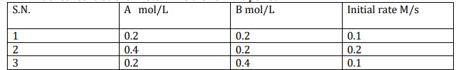 | 3
Ans. | -For A-Rate =k[A]x For B Rate =k[B]y From case 1 and 2, 2× Rate =k[2A]x From case 1 and 3, Rate =k[2B] y X=1, y=0 Order n=x+y=1+0=1
4 | 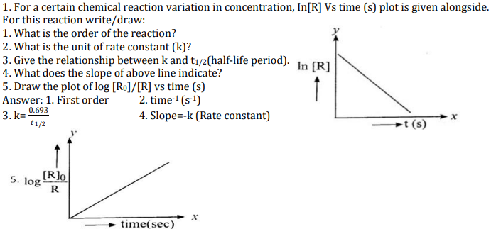 | 5
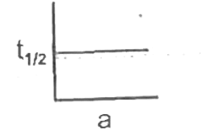

*****************************************

CHAPTER-4.d&f block elements

Multiple Choice Questions
1. Which of the following statement about transition element is not correct?
(a) They show variable oxidation states.
(b) They exhibit diamagnetic and paramagnetic properties.
(c) All ions are coloured (d) They exhibit catalytic property.
Ans – (c)
2.The magnetic moment is associated with its spin angular momentum and orbital angular momentum.
Spin only magnetic moment value of Cr³⁺ ion is
(a) 2.87 B.M.
(b) 3.87 B.M.
(c) 3.47 B.M
(d) 3.57 B.M
Ans – (b)
3. Manganese exhibits maximum oxidation state in:
(a) K₂MnO₄
(b) KMnO₄
(c) MnO₂
(d) Mn₃O₄
Ans – (b)
4.Electronic configuration of a transition element X in +3 oxidation state is [Ar]3d⁵. What is its atomic number?
(a) 25
(b) 26
(c) 27
(d) 24
Ans – (b)
5.Metallic radii of some transition elements are given below. Which of these elements will have highest density?
Element Fe ‘Co’ Ni’ Cu
Metallic radii/pm 126’ 125,125 ,128
(a) Fe
(b) Ni
(c) Co
(d) Cu
Ans – (d)

6. Mischmetal contains La and traces of S, C, Ca and Al. Choose the correct composition.
A. 95% Lanthanoid + 5% Iron
B. 5% Lanthanoid + 95% Iron
C. 96% Fe, Ni & Co and 4% Carbon
D. None of these
Ans.( a )

7.Write the formula of an oxo-anion of Chromium (Cr) in which it shows the oxidation state equal to its group number.
A. Cr₂O₃
B. CrO₂
C. Cr₂O₇²⁻ .
D. CrO₃
Ans. C

*********************************

CHAPTER-4.d and f-BLOCK ELEMENTS

A) Both assertion and reason are correct statements, and reason is the correct explanation of the assertion.
B )Both assertion and reason are correct statements, but reason is not the correct explanation of the assertion.
C)Assertion is correct, but reason is wrong statement.
D)Assertion is wrong, but reason is correct statement.

1.Assertion: Transition metals have high enthalpy of atomisation.
Reason: d-block elements have strong metallic bonds. (A)
2.Assertion: Manganese has an exceptionally low melting point in 3d series.
Reason: Manganese has weak metallic bonds due to electronic repulsion. (C)
3.Assertion: Scandium does not show variable oxidation state.
Reason: Scandium has only one electron in the 3d orbital. (B)
4.Assertion: Fe2+ readily oxidizes to Fe3+ in solution.
Reason: Fe3+ has a stable d5 configuration. (A)
5.Assertion. Among the 3d series only copper shows +1 oxidation state.
Reason: Cu+ ion has high negative hydration enthalpy in solution compared to Cu (B)
6.Assertion: Cobalt (II) readily oxidises to Co (III) while forming complexes.
Reason: Co(III) has a stable t2g3 configuration in complexes. (C)
7.Assertion: Transition metals show very low degree of para magnetism.
Reason: Transition metal atoms have large number of unpaired electrons. (D)
8.Assertion: Transition metals are very good catalysts.
Reason: Transition metals are strong metals with high melting points. (B)
9.Assertion: Transition metals readily forms alloys.
Reason: Transition metals can be melted easily and mixed together. (B)
10.Assertion: Potassium permanganate is a good oxidising agent in acidic medium.
Reason: Permanganate readily reduces to manganese dioxide in acidic
medium. (C)
- Assertion: Sodium dichromate cannot be used as a primary standard in titrations.
Reason: Sodium dichromate is hygroscopic in nature. (A)
- Assertion: Orange solution of dichromate turns yellow when pH of the solution is increased.
Reason: The colour of dichromate gets bleached when alkali is added. (C)
- Assertion: Lanthanide contraction is more than actinoid contraction.
Reason: Actinoids have 5f orbitals being filled which are more dispersed in space compare to 4f orbitals. (D)
- Assertion: Misch metal is a pyrophoric alloy.
Reason: Misch metal is prepared from lanthanoids. (B)
- Assertion: Actinoids show more variety in oxidation state than lanthanoids.
Reason: Actinoids have comparatively larger size than lanthanoids. (B)
- Assertion: Zirconium and Hafnium have similar properties.
Reason: Zirconium and Hafnium lie in the same group of the periodic table. (B)
- Assertion: Highest oxidation states of d-block metals are usually seen in oxides and oxoanions.
Reason: Oxygen is capable of forming pπ – dπ bonds with transition metals. (A)
- Assertion: Higher oxidation states in transition metals are more covalent than lower oxidation states. (A)
Reason: Higher oxidation states involve more d-electrons than lower oxidation states.
- Assertion: Manganate ion is paramagnetic while permanganate ion is diamagnetic.
Reason: Manganate ion has two unpaired electrons. (C)
- Assertion: HCl cannot used for acidification in permanganometric titrations.
Reason: HCl gets oxidised to chlorine in the presence of permanganate. (A)

**********************************

1 . Read the passage given below and answer the following questions:

The transition elements have incompletely filled d –subshells in their ground state or in any of their oxidation states. The transition elements occupy positions in between s-and p-blocks in groups 3-12 of the periodic table . In general , the electronic configuration of these elements is (n-1)d1-10 ns0-2 .The d – orbital of the penultimate energy level in their atoms receives electrons giving rise to three rows of transition metals i.e. 3d, 4d, 5d series. However Zn ,Cd and Hg are not regarded as transition elements. All transition elements have typical metallic properties such as high tensile strength, ductility, malleability. Except mercury ,which is liquid at room temperature ,other transition have typical metallic structure . Transition elements exhibit certain characteristics properties like variable oxidation states, complex formation , formation of coloured ions etc .

Answer the following questions –
(a)Which of the following ion is coloured and why ? (1)
Sc3+ ,Cu2+ ,V5+ ,Ti4+
(b) Why Zn ,Cd and Hg are soft and have low melting and boiling points ? (1)
(c )(i) Why transition elements shows variable oxidation states ? (1)
(ii) Which of the 3d series of the transition metals exhibits the largest number of oxidation states and why ? (1)
Or
(i) Cu+ is not stable in aqueous solution .Why ? (1)
(ii) Transition elements form alloys .Why ? (1)

Ans.
(a)Cu²⁺ due to presence of unpaired elelctron .
(b)No unpaired electron in 3d subshell /weak metallic bonding .
(c) (i) Due to participation of (n-1)d and ns electron in bond formation .
(ii) In 3d series Mn shows the highest oxidation state of +7 as it has maximum no. of unpaired e- .

or
(i) Many Cu(I) compounds are unstable in aqueous solution and undergo disproportionation.
2Cu+ → Cu2+ + Cu
The stability of Cu2+ rather than Cu+ is due to more –ve hydration enthalpy of Cu2+ than Cu+ which is much more and compensate for the II ionisation enthalpy .
(ii) Due to similar metallic radii .

2. Read the passage given below and answer the following questions:
The f-block elements are those in which the differentiating electron
enters the (n -2)f orbital. There are two series of f-block elements
corresponding to filling of 4f and 5f-orbitals. The series of 4forbitals is called lanthanides. Lanthanides show different oxidation states depending upon stability of f⁰ ,f⁷ and f¹⁴ configurations, though the most common oxidation states is +3. There is a regular
decrease in size of lanthanides ions with increase in atomic number which is known as lanthanide contraction.
(a) The atomic numbers of three lanthanide elements X, Y and Z are 65, 68
and 70 respectively, t What is their Ln³⁺ electronic configuration is (1)
Ans. 4f ⁹ ,4f¹¹,4f¹³
(b) Name a member of the lanthanoid series which is well known to exhibit
+4 oxidation state. (1)
Ans. Cerium
(c) What is the reason of lanthanoid contraction? (1)
Ans. The Lanthanide Contraction is caused by a poor shielding effect of the 4f electrons.
(d) Why Zr & Hf exist together? (1)
Ans. Due to lanthanoid contraction, their sizes are similar.

3.Read the passage given below and answer the following questions:
The transition elements have incompletely filled d-subshells in their ground
state or in any of their oxidation states. The transition elements occupy position
in between s- and p-blocks in groups 3-12 of the Periodic table. Starting from
fourth period, transition elements consists of four complete series : Sc to Zn,
Y to Cd and La, Hf to Hg and Ac, Rf to Cn. In general, the electronic
configuration of outer orbitals of these elements is (n - 1) d1-10 ns1-2. The
electronic configurations of outer orbitals of Zn, Cd, Hg and Cn are represented
by the general formula (n - 1)d10 n2. All the transition elements have typical
metallic properties such as high tensile strength, ductility, malleability. Except
mercury, which is liquid at room temperature, other transition elements have
typical metallic structures. The transition metals and their compounds also
exhibit catalytic property and paramagnetic behaviour. Transition metal also
forms alloys. An alloy is a blend of metals prepared by mixing the components.
Alloys may be homogeneous solid solutions in which the atoms of one metal
are distributed randomly among the atoms of the other.
(a) Why are Zn, Cd and Hg non-transition elements? (1)
Ans. It is because neither they nor their ions have incompletely filled d orbitals.
(b) Which transition metal of 3d series does not show variable oxidation
state? (1)
Ans. Scandium (Sc) and Zinc (Zn).
(c) Why do transition metals and their compounds show catalytic activity?
Ans. It is because they show variable oxidation state, can form intermediate
complexes and have large surface area for adsorption of gases. (1)
(d) Why are melting points of transition metals high? (1)
Ans. It is due to strong inter atomic forces of attraction due to presence of
unpaired electron.
OR
(d) Why is Cu2+ ion coloured while Zn2+ ion is colorless? (1)
Ans. It is because Cu2+ has one unpaired electron and undergoes d-d
transition by absorbing light from visible region and radiate blue colour,
whereas Zn2+ is colourless due to absence of unpaired.

4. Read the passage given below and answer the following questions:
Observe the graph of transition metal and their melting points and answer the
questions based on weak metallic bond which is due to absence of the graph
and related concepts.

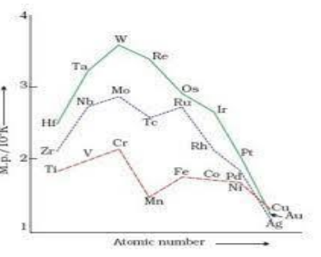

(a) Why does W (tungsten) have highest melting point? (1)
Ans. It is due to presence of unpaired electrons and there is more frequent
metal-metal bonding in 5dseries than 3d and 4d series.
(b) Which element in 3d series has lowest enthalpy of atomization and why?
Ans. Zinc has lowest enthalpy of atomization due to weak metallic bond
which is due to absence of unpaired electrons. (1)
(c) Why is mercury liquid? (1)
Ans. It is due to larger size, absence of unpaired electron and weak inter
atomic attraction and weaker metallic bond.
(d) Why are transition metals less electro positive? (1)
Ans. It is due to smaller atomic size and higher ionization enthalpies.
OR
(d) How does density vary from left to right in 3dseries and why? (1)
Ans. Density goes on increasing from Sc to Cu because atomic mass
increases more than atomic volume.
5.Read the passage given below and answer the following questions:
Observe the table given below belonging to 3d series, their first, second, third
ionization enthalpy and E° M2+ /M and E° M3+ /M2+ and answer the questions
that follow based on table and related concepts
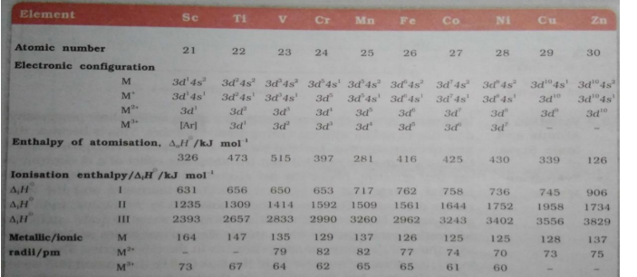

(a) Why does zinc have highest first ionization enthalpy? (1)
Ans. It is because Zn has completely filled ‘4s’ orbital which is stable.
(b) Why is 3rd ionization enthalpy of Mn high? (1)
Ans. It is because after losing 2 electrons, it becomes 3d5 which is more stable.
(c) Why is Cr3+ more stable than Cr2+?(1)
Ans. It is because Cr3+(t2g
3 ) half-filled orbitals are more stable than Cr2+(3d4).
(d) Why is E° Mn2+ /Mn = –1.18V? (1)
Ans. It is due to low enthalpy of atomization, sublimation enthalpy, ionization
enthalpy.
OR
(d) Why is E ° Cu2+/Cu= +0.34V? (1)
Ans. It is due to high ionization enthalpy and low hydration enthalpy
************************************************************

1 | a) Calculate the magnetic moment of a divalent ion in aqueous solution if its at.no is 25. B) Zn2+ salts are white while Cu2+ salts are coloured. Why? | 2
Ans | a) μ = 5(5 + 2) = 5.92BM] Cu2+ (3d9 4s0) has one unpaired electron in d-subshell absorbs radiation in visible region resulting in d-d transition and hence Cu2+ salts are coloured. b) Zn2+ (3d¹⁰ 4s⁰) has completely filled d-orbitals. No radiation is absorbed for d-d transition and hence Zn²⁺ salts are Colourless.
2 | In the following ions: Mn3+, V3+, Cr3+, Ti4+ (Atomic no.: Mn=25, V=23, Cr=24, Ti=22)  A. Which ion is most stable in an aqueous solution?  B. Which ion is strongest oxidizing agent?  C. Which ion is colorless?  D. Which ion has the highest number of unpaired electrons | 2
Ans. | A. Cr³⁺ because of half filled t_{2g} level  B. Mn3+, as the change from Mn3+ to Mn2+ results in stable half filled (d5) configuration.  C. Ti4+, as Ti4+ has empty d-orbitals therefore d-d transition cannot occur in Ti4+.  D. Mn³⁺ (3d⁴ 4s⁰). It has 4 unpaired electrons.
3 | The elements of 3d transition series are given as: Sc, Ti, V, Cr, Mn, Fe, Co, Ni, Cu, Zn Answer the following: A. Copper has exceptionally positive EoM²/M value. Why?  B. Which element is a strong reducing agent in +2 oxidation state and why?  C. Zn2+ salts are colourless. Why?  D. Which element has the highest melting point | 2
Ans. | s A. Because the sum of sublimation enthalpy and hydration enthalpy to convert Cu(s) to Cu2+(aq) is so high that it is not balanced by its hydration enthalpy.  B. Cr is strongest reducing agent in +2 oxidation state. Cr2+ has configuration 3d4. After losing one electron it forms Cr3+ which has stable half filled t2g, level.  C. Zn2+ (3d10) has completely filled d-orbitals. As a result of this, d-d transition cannot occur and hence Zn2+ salts are colourless.  D. Mn
4. | Account for the following: (a) Mn2O7 is acidic whereas MnO is basic.  (b) Though copper has completely filled d-orbital (d10) yet it is considered as a transition metal.  (c) Actinoids show wide range of oxidation states. | 3
Ans | (a) Mn has + 7 oxidation state in Mn2O7 and +2 in MnO. In higher oxidation state of the metal, valence electrons involved in bonding and are not available. Instead, effective nuclear charge is high and hence it accept electrons and behave as a Lewis acid.  (b) Copper exhibits +2 oxidation state wherein it will have incompletely filled d-orbitals (3d9), hence transition metal.  (c) This is due to comparable energies of 5f, 6d and 7s-orbitals.
5 | 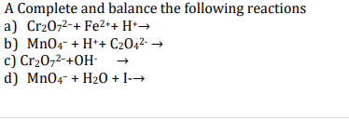  B. Name the oxo metal anion of one of the transition metals in which the metal exhibits the oxidation state equal to the group number
Ans | 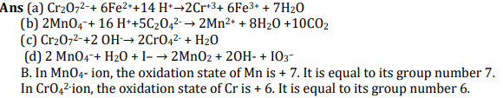

*****************************

CHAPTER-5.COORDINATION CHEMISTRY

MULTIPLE CHOICE QUESTIONS
1. When 0.1 mol CoCl3 (NH3 )5 is treated with excess of AgNO3; 0.2 mol of AgCl are obtained. The conductivity of solution will correspond to-
(a) 1: 3 electrolyte (b) 1 : 2 electrolyte
(c) 1: 1 electrolyte (d) 3 : 1 electrolyte
Ans :(b)
2. The correct IUPAC name of [Pt(NH3 )2 Cl2 ] is
(a) Diammine dichlorido platinum (II)
(b) Diammine dichloride platinum (IV)
(c) Diammine dichloride platinum (0)
(d) Dimmine dichloride platinum (IV)
Ans :(a)
3. This stabilisation of coordination compounds due to chelation is called the chelate effect. Which of the following is the most stable complex species?
(a) [Fe (CO)₅ ]
(b) [Fe(CN)₆ ] 3–
(c) [Fe(C2 O4 )₃ ] ³⁻
(d) [Fe(H2 O)₆ ] 3+
Ans :(c)
4. Indicate the complex ion which shows geometrical isomerism.
(a) [Cr(H2 O)4 Cl2 ] +
(b) [Pt(NH3 )3 Cl]
(c) [Pt(NH3 )6 ] 3+
(d) [CO(CN)5 (NC)]3-
Ans :(a)

5. Which of the following is a complex of metal other than transition metal?
(a) Haemoglobin
(b) Chlorophyll
(c) Ferrocene
(d) Vitamin B12
Ans :(b)

6. Which of the following is not a double salt but a coordinate compound?
(a) KCl.MgCl2.6H2O
(b) FeSO4.(NH4)2SO4.6H2O
(c) K2SO4.Al2(SO4)3 .24H2O
(d) K4 [Fe(CN )6]
Ans :(d)
7. The donor atoms in ethylene diamine tetra acetate ion is
(a) two N and two O
(b) two N and four O
(c) four N and two O
(d) three N and three O
Ans :(b)
8. The complex ion [Cu(NH3)4] +2 is-
(a) tetrahedral and paramagnetic
(b) tetrahedral and diamagnetic
(c) square planar and paramagnetic
(d) square planar and diamagnetic
Ans :(c)
9. The hybrid state of Co in high spin complex, K3[CoF6] is
(a) sp³ d ² (b) sp³
(c) d²sp³ (d) sp³d
Ans :(a)
10. In an octahedral crystal field, the t₂g orbital are
(a) raised in energy by 0.4 ∆o
(b) lowered in energy by 0.4 ∆o
(c) raised in energy by 0.6 ∆o
(d) lowered in energy by 0.6 ∆o
Ans :(b)

11. If ∆o < P, then the correct electronic configuration for d4 system will be
(a) t₂g 4 eg⁰
(b) t₂g 3 eg 1
(c) t₂g ⁰ eg ⁴
(d) t₂g ² eg ² Ans :(b)
12. The tetrahedral complexes are generally high spin. This is because
(a) ∆t < P
(b) ∆t > P
(c) ∆t = P
(d) none of these
Ans :(a)
13.The primary and secondary valency of copper in the complex [Cu (NH3)4]SO4 are
(a) 2, 4
(b) 4, 2
(c) 0, 4
(d) 1, 4
Ans :(a)
14.The hybridization state of the Cu in the compound [Cu(NH3)4]SO4 is
(a) sp3
(b) sp2d
(c) sp3d 2
(d) dsp2 Ans :(d)
15. Which of the following statement is correct?
(a) [Cu (NH3)4] 2+ is diamagnetic while [Fe(CN)₆]⁴⁻ is paramagnetic
(b) [Cu (NH3)4] 2+ is paramagnetic while [Fe(CN)₆] ⁴⁻ is diamagnetic
(c) both are paramagnetic
(d) both are diamagnetic
Ans :(b)

********************************

COORDINATION COMPOUNDS
A) Both assertion and reason are correct statements, and reason is the correct explanation of the assertion.
B ) Both assertion and reason are correct statements, but reason is not the correct explanation of the assertion.
C)Assertion is correct, but reason is wrong statement.
D)Assertion is wrong, but reason is correct statement.

- Assertion: EDTA is used to treat lead poisoning.
Reason: EDTA forms very stable complexes with lead. (A)
- Assertion: Coloured complexes become colourless once the ligands are removed.
Reason: The d – d transitions are not possible since d orbitals become degenerate. (A)
- Assertion: Carbon monoxide forms low spin complexes with metals.
Reason: Carbon monoxide is neutral oxide. (B)
- Assertion: Carbon monoxide is a deadly poison.
Reason: CO can form strong complexes with haemoglobin. (A)
- Assertion. Tetrahedral complexes cannot exhibit geometrical isomerism.
Reason: Tetrahedral complexes are chiral in nature. (C)
- Assertion: An octahedral complex with two bidentate ligands is always optically active.
Reason: The cis – isomer of the octahedral complex is chiral. (D)
- Assertion: Ionisation isomerism is shown by complexes having ambidentate ligands.
Reason: Ambidentate ligands have two possible ligating centres. (D)
- Assertion: The colour of a complex changes when one ligand is replaced by another.
Reason: The magnitude of d-orbital splitting is decide by the nature of the ligand. (D)
- Assertion: [Fe(CN)6]³⁻ is more paramagnetic than[FeF6]³⁻.
Reason: [FeF6]³⁻ has more number of unpaired electrons. (D)
- Assertion: [Co(NH3)6]³⁺ is an inner orbitalcomplex.
Reason: [Co(NH3)6]³⁺ forms an octahedral complex. (B)
*************************

CASE BASED Qs

Crystal field splitting by various ligands
Q.I) Metal complexes show different colours due to d-d transitions. The complex absorbs light of specific wavelength to promote the electron from t2g to eg level. The colour of the complex is due to the transmitted light, which is complementary of the colour absorbed. The wave number of light absorbed by different complexes of Cr ion are given below:
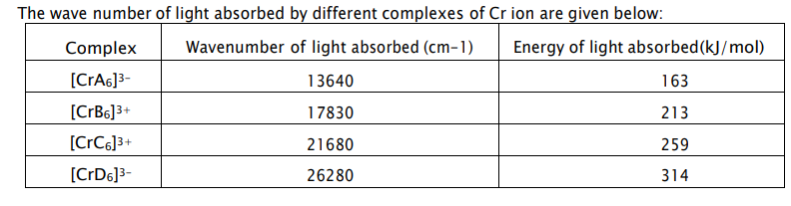
Answer the following questions:
(a) Out of the ligands “A”, “B”, “C” and “D”, which ligand causes maximum crystal field splitting? Why? (1)
OR
Which of the two, “A” or “D” will be a weak field ligand? Why?
(b) Which of the complexes will be violet in colour? [Cr A ₆]³⁻ or [CrB₆]³⁺ and why?
(Given: If 560 -570 nm of light is absorbed, the colour of the complex observed is violet.) (1)
(c) If the ligands attached to Cr³⁺ ion in the complexes given in the table above are water, cyanide ion, chloride ion, and ammonia (not in this order)
Identify the ligand, write the formula and IUPAC name of the following: (2)
(i) [CrA6]³⁻ (ii) [CrC6]³⁺
Ans.
(a) D. Energy is directly proportional to the wave number. Maximum energy of light is required for an electron to jump from t2g to eg in case of [CrD6]3- (1/2+1/2)
OR
(a) A, The splitting caused in least in this case as the energy required for electron to jump from t 2g to eg., is minimum. (1/2 +1/2)
(b) [CrB6]³⁺, wavelength of light absorbed is 1/17830 = 560nm for the complex while 1/13640 = 733
nm for [CrA6]³⁻ complex. (1/2+1/2)
(c) (i) [CrCl₆]³⁻ , Hexachloridochromate(III) ion (1 each)
(ii) [Cr(NH ₃)₆]3+, Hexaamminechromium(III) ion
A = Cl– , B= H ₂O, C= NH ₃, D= CN–

QI). Read the passage given below and answer the following questions:
Werner, a Swiss chemist in 1892 prepared and characterised a large number of coordination compounds and studied their physical and chemical behaviour. He proposed that, in coordination compounds, metals possess two types of valencies, viz. primary; valencies, which are normally ionisable and secondary valencies which are non-ionisable. In a series of compounds of cobalt (III) chloride with ammonia, it was found that some of the chloride ions could be precipitated as AgCI on adding excess of AgNO3 solution in cold, but some remained in solution. The number of ions furnished by a complex in a solution can be determined by precipitation reactions. The measurement of molar conductance of solutions of coordination compounds helps to estimate the number of ions furnished by the compound in solution.
(i)Why the complex [Co(NH₃)3CI₃] does not give precipitate with silver nitrate solution
Ans. The given complex is non-ionisable.
(ii) The complex [Co(NH₃)₄Cl₂]Cl will give precipitate corresponding to how
many mol of AgCl with AgNO3 solution.
Ans. It ionises as [Co(NH3)₄Cl₂]⁺ + Cl– ,so it will give ppt.of 1 mol of AgCl..
(iii) What is the secondary valency in [CrCl₂CH₂O)₄] Cl· 2H2O.
Ans.6
(iv) CoCl3·3NH3 is not conducting while CoCl3·5NH3 is conducting. Why?
Ans.: The complex of CoCl3·3NH3 is [ CoCl3(3NH3)3] while that of CoCl3·5NH3 is [CoCl3(3NH3)5]Cl2.
III). Read the passage given below and answer the following questions:
For understanding the structure and bonding in transition metal complexes, the magnetic properties are very helpful. Low spin complexes are generally
diamagnetic because of pairing of electrons, whereas high spin complexes are
usually paramagnetic because of presence of unpaired electrons. Larger the
number of unpaired electrons, stronger will be the paramagnetism. However
magnetic behaviour of a complex can be confirmed from magnetic moment
measurement.
Magnetic moment μ=n(n+2)−−−−−−−√ B.M. μ=n(n+2) B.M. where
n = number of unpaired electrons. Greater the number of unpaired electrons,
more will be the magnetic moment.
(i) Both [Cr(H2O)6]2+ and [FeH2O)6]2+ have same magnetic moment. Why?
Ans.: Number of unpaired electrons in Cr2+ and Fe2+ are same.
(ii) [Fe(H2O)6]SO4 is paramagnetic. Why?
Ans. The Fe in [Fe(H2O)5NO]SO4 has three unpaired electrons.
(iii): [Co(en)3]3+ is diamagnetic. '
Ans. It is an inner orbital complex.( en is a strong field ligand, therefore,
pairing of electrons will take place.
(iv) [Ni(CN)4]2-is diamagnetic complex.
Reason: It involvesd sp2 hybridisation and there is no unpaired electron.

QIV).In coordination compounds, metals show two types of linkages, primary and secondary. Primary valencies are ionisable and are satisfied by negatively charged ions. Secondary valencies are non-ionisable and are satisfied by neutral or negative ions having lone pair of electrons. Primary valencies are non-directional while secondary valencies decide the shape of the complexes.
(i) If PtCl2. 2NH3does not react with AgNO3, what will be its
formula ? (1)
Ans.[Pt(NH3)2Cl2]
(ii) What is the secondary valency of [Co(en)3]³⁺ ? (1)
Ans. 6
(iii) Write the formula of Iron(III)hexacyanidoferrate(II). (1)
Ans. Fe₄ [Fe(CN)₆]₃
(2) Write the IUPAC name of [Co(NH3)5Cl] Cl2. (1)
Ans. Pentaamminechloridocobalt(III) chloride
*******************************

1 | When a co-ordination compound CoCl3.5NH3 is mixed with AgNO3, 2 mole of AgCl is precipitated per mole of the compound. Write (a) structural formula of the complex. (b) IUPAC name of the complex | 2
Ans. | (a) [Co(NH3)₅Cl]Cl₂ (b) pentaamminechloridocobalt(III) chloride.
2 | Explain the following: (i) Low spin octahedral complexes of nickel are not known. (ii) CO is a stronger ligand than NH3 for many metals. | 2
Ans | (i) Ni in its atomic or in it’s ionic state cannot afford two vacant 3d orbitals hence d2sp3 hybridisation is not possible. (ii) Because in case of CO back bonding takes place in which the central metal uses its filled d orbital with empty anti bonding 𝜋* molecular orbital of CO
3 | (a) Why are low spin tetrahedral complexes not formed (b) [Fe(H2O)6] 3+ is strongly paramagnetic whereas[Fe(CN)6] 3- is weakly paramagnetic. Explain. (At. no. Fe = 26) | 3
(a) Low spin tetrahedral complexes are rarely observed because orbital splitting energies for tetrahedral complexes are not sufficiently large for forcing pairing. (b) In both the cases, Fe is in oxidation state +3. Outer electronic configuration of Fe³⁺is 3d⁵
In the presence of CN–, the 3d electrons pair up leaving only one unpaired electron. The hybridisation involved is d2sp3 forming inner orbital complex which is weakly paramagnetic. In the presence of H2O (a weak ligand), 3d electrons do not pair up. The hybridisation involved is sp3d2 forming an outer orbital complex. As it contains five unpaired electrons so itis strongly paramagnetic. .
4 | (a)On the basis of CFT, write the electronic configuration for d5 if ∆o < P For the complex [Fe(en)₂Cl₂] Cl, identify the following:  (i) Oxidation number of iron  (ii) Hybridization in Fe  (iii) Shape of the complex  (iv) Denticity of ligand ethylene-di-amine | 5
Ans | (a) t2g ³ eg² (b) (i) +3, (ii) d²sp³ (iii) Octahedral (iv) 2
5 | 1 Answer the followings: (2 + 2 + 1)  (a) The Spin magnetic moment of [MnBr4] 2- is 5.9 BM. Predict the geometry of the complex ion?  (b) [Ni (CO)4] is tetrahedral but [Ni (CN)4] 2- is square planar. Explain.  (c) Give one example of hexadentate ligand | 5
Ans | (a) Ans: Since coordination number of Mn2+ ion is 4 it will either sp3 with tetrahedral shape or dsp2 with square planar shape but it is tetrahedral as d orbital will occupy by the presence of 5 unpaired electrons.  (b) In [Ni (CO)4], Ni is in zero oxidation state whereas in [NiCN4] 2– it is in +2 oxidation state. In the presence of strong ligand, CO, the unpaired d-electrons of Ni pair up and it uses one S and three p orbitals for sp3 hybridisation so it is tetrahedral and CN–is also strong ligand but the oxidation state is +2 so it uses one d one s and two p orbitals for dsp2 hybridisation. So it is square planar.  (c) EDTA⁴⁻

CHAPTER-6.HALOALKANES & HALOARENES

MCQs

1. Which of the following is most reactive towards nucleophilic substitution reaction?
(a) C6H5Cl
(b) CH2=CHCl
(c) ClCH2CH=CH2
(d) CH3CH=CHCl
ANS.(C)

2. Tertiary alkyl halides are practically inert to substitution by SN2 mechanism because of
(a) insolubility
(b) instability
(c) inductive effect
(d) steric hindrance
ANS.(d)
3.consider the following bromides
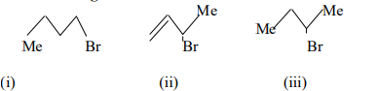
The correct form of SN1 reactivity is
a) I >II >III
b) II > III > I
c) II > I > III
d) III > II > I
ans. (b)
4.In which of the following cases will the compound be a tertiary (3°) halogen compound? (X=halogen atom)
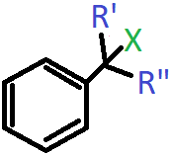
a) R’=R”=H
b) R’=CH₃, R”=H
c) R’=H, R”=CH₃
d) R’=R”=CH₃
View Answer
Answer: d
5. What is the IUPAC name of the following compound?

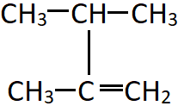

a) 2-Propylprop-1-ene
b) 2,3-Dimethylbut-1-ene
c) 2,4-Dimethylbut-1-ene
d) 1,3-Dimethylbut-2-ene

ANS. b
6. The following reaction to form haloalkanes is an example of which type of reaction?
Propane + Cl₂ (in the presence of UV light) = 1-Chloropropane + 2-Chloropropane
a) Free radical substitution
b) Halogen exchange
c) Finkelstein reaction
d) Swarts reaction
View Answer
Answer: a
7. Identify ‘X’ in the following reaction

a) AgF
b) Hg₂F₂
c) CoF₂
d) SbF₃

_{ANS. B}
8.If the compound shown has a boiling point of 346K, predict the boiling point of n-Butyl bromide?
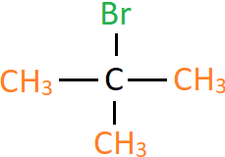

a) 300K
b) 325K
c) 350K
d) 375K
Answer: d

9.The rate of the following reaction depends on the concentration of which reactant(s)/?
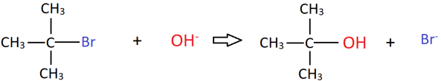
a) tertbutyi bromide
b) OH⁻
c)tertbutyl alcohol
d) Br⁻
Answer: a

10, What is the most suitable term for the following transformation?

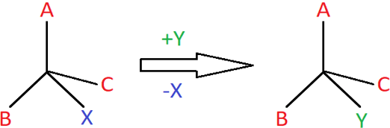

a) Inversion of configuration
b) Retention of configuration
c) Racemisation
d) Elimination reaction
Answer: b

**************************************

HALOGEN COMPOUNDS

A) Both assertion and reason are correct statements, and reason is the correct explanation of the assertion.
B )Both assertion and reason are correct statements, but reason is not the correct explanation of the assertion.
C)Assertion is correct, but reason is wrong statement.
D)Assertion is wrong, but reason is correct statement.

- Assertion: Iodoalkanes undergo nucleophilic substitution more readily than bromoalkanes
Reason: Iodine is a better leaving group due to its larger size which makes the covalent bond weaker. (A)
- Assertion: SN2 mechanism leads to racemisation.
Reason: The incoming nucleophile attacks the compounds from the side opposite to the outgoing nucleophle in SN2 mechanism. (D)

- Assertion: Haloalkanes react with KCN to form cyanoalkanes.
Reason: KCN completely ionises in solution. (A)
- Assertion: Chlorobenzene is less polar than chloro methane.
Reason: Chlorobenzene has a longer C-Cl bond due to resonance. (C)
- Assertion: Presence of nitro group at ortho or para position makes nucleophilic substitution in chlorobenzene easier.
Reason: Nitro group donates electrons to stabilize the intermediate ion formed by the addition of the incoming nucleophile. (C)
- Assertion: Chloroform must be stored in dark coloured bottles.
Reason: Chloroform reacts with air to form phosgene. (B)
- Assertion: Chlorobutane has lower boiling point than 2-Chloro-2-methylpropane.
Reason: The intermolecular forces in straight chain compounds are stronger than in branched compounds. (A)
- Assertion: Benzyl chloride undergoes nucleophilic substitution through SN1 mechanism.
Reason: Benzyl carbocation is resonance stabilized. (A)
- Assertion: Haloalkanes are only sparingly soluble in water.
Reason: Haloalkanes cannot form hydrogen bonds with water molecules. (B)
- Assertion: Propene reacts with HBr to form 2-bromopropane.
Reason: The intermediate carbocation formed will be secondary since it is more stable than primary. (A)

Haloalkanes and Haloarenes
I Read the following passage and answer the following questions.
Nucleophilic Substitution Reactions
In nucleophilic substitution reactions, the incoming nucleophile having at least one atom with a lone pair of electrons attacks at the carbon atom bonded to halogen.
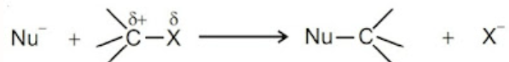
he nucleophilic substitution proceeds mainly by two different mechanisms
S_{N}1 is a two-step unimolecular reaction. The first step is the slow ionisation of substrate and is the rate-determining step. The second step is the rapid reaction between the carbocation and the nucleophile.  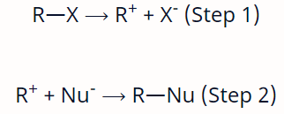 | S_{N}2 is a single step bimolecular reaction in which the incoming nucleophile attacks the C–atom of substrate in a direction opposite to the outgoing nucleophile. The reaction passes through a transition state in which both the incoming and outgoing nucleophiles are bonded to the same C–atom.  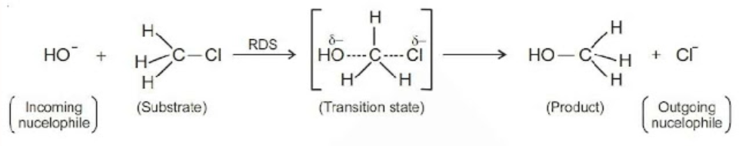

- I) Tertiary alkyl halides are practically inert to substitution by S_{N}2 mechanism. Explain. (1)
- Arrange the compounds in correct order of increasing SN1 reactivity.(1)
RCH₂X , R₂CHX , R₃CX
- Which of the following is most reactive towards nucleophilic substitution reaction? Give reason (2)
CH₂ = CHCl , ClCH₂CH = CH₂
OR
Why do AgCN and KCN acting as nucleophilic reagents form two different products when reacted with alkyl haide.(2)

II Read the following passage and answer the following questions.
Alkyl halides are prepared by the free radical halogenation of alkanes, addition of halogen acids to alkenes, replacement of -OH group of alcohols with halogens using phosphorus halides, thionyl chloride, or halogen acids. Aryl halides are prepared by electrophilic substitution to arene. Fluorine and iodides are best prepared by the halogen exchange method. These compounds find wide applications in industry as well as in day-to-day life. These compounds are generally used as solvents and as starting materials for the synthesis of a large number of organic compounds.
- The best method for the conversion of an alcohol into an alkyl chloride is by treating the alcohol with ________________________. (1)
- The catalyst used in the preparation of an alkyl chloride by the action of dry HCl on alcohol is ___________________(1)
- An alkyl halide reacts with metallic sodium in dry ether. Explain with equation. (2)
OR
- Fluorobenzene (C₆H₅F) can be synthesized in the laboratory. Write equation of the synthesis. (2)

Answers
I
i)Nucleophile faces more steric hinderance due to alkyl groups the carbon.
ii) RCH₂X , R₂CHX , R₃CX
iii)ClCH₂CH = CH₂ , As Allyl carbocation is resonance stabilised.
OR
AgCN is a covalent compound while KCN is ionic.

II
i)Thionyl chloride.
ii)Anhydrous zinc chloride.
iii)2RX + Na R-R + NaX
This is wurtz reaction in which hydrocarbon with double the number of carbon atoms as present in the alkyl halide is formed.
OR
Swartz reaction
RCl + AgF RF + AgCl

III)Primary alkyl halide C4H9Br (a) reacted with alcoholic KOH to give compound (b). Compound (b) is reacted with HBr to give (c) which is an isomer of (a). When (a) is reacted with sodium metal it gives compound (d), C8H18 which is different from the compound formed when n-butyl bromide is reacted with sodium. Give the structural formula of (a) and write the equations for all the reactions.
Also identify b & c. (1x4=4))

Ans.

Two primary alkyl halides with molecular formula C4H9Br are possible. They are n-butyl bromide and isobutyl bromide.
When (a) is reacted with sodium metal it gives compound (d), C8H18 which is different from the compound formed when n-butyl bromide is reacted with sodium. Hence, compound a is isobutyl bromide and compound d is 2,5-dimethylhexane.(1)
2CH3CH2CH2CH2Br+2NaWurtz reaction−−−−−−−−−→CH3CH2CH2CH2CH2CH2CH2CH3(n−octane)
2CH3CH(CH3)CH2Br+2Nawurtz reaction−−−−−−−−−→CH3CH(CH3)CH2CH2CH(CH3)CH3(2,5−dimethylhexane)(1)
(a) reacted with alcoholic KOH to give compound (b).
CH3CH(CH3)CH2BralcKOH−−−−−→CH3C(CH3)=CH2(2−methyl−1−propene)(1)
Compound (b) is reacted with HBr to give (c) which is an isomer of (a).
CH3−C(CH3)=CH2HBr−−−−−−−−−−−−−→Markownikoff′s ruleCH3−CBr(CH3)CH3(tert−butylbromide)(1)

*******************************************

1 | Predict the order of reactivity of the following compounds in SN1 reaction:  C6H5CH2Br, C6H5C(CH3) (C6H5) Br, C6H5CH(C6H5) Br, C6H5CH(CH3) Br | 2
Ans | C6H5C(CH3) (C6H5) Br> C6H5CH(C6H5) Br> C6H5CH(CH3) Br> C6H5CH2Br
2 | Identify the major product formed when 2-cyclohexylchloroethane undergoes a dehydrohalogenation reaction. Name the reagent which is used to carry out the reaction. | 2
Ans | The major product formed when 2-cyclohexylchloroethane undergoes dehydrohalogenation reaction is 1- cyclohexylethene. The reagent which is used to carry out the reaction is ethanolic KOH
3 | A compound ‘A’ with molecular formula C4H10O is a unreactive towards sodium metal. It does not discourse Bromine water and does not react with NaHSO3 solution. On refluxing ‘A’ with excess of HI gives ‘B’ which react with aq. NaOH to form ‘C’. ‘C’ can be converted into ‘B’ by reacting with P and I2 . ‘C’ on heating with conc. H2SO4 forms ‘D’ decolorizes bromine water. Identify A to D and write the reactions involved. | 5
Ans | 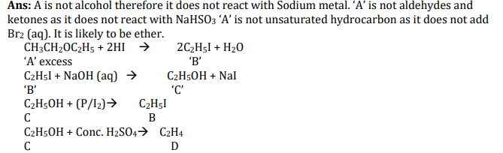
4 | (a) What are ambident nucleophiles? Explain with an example.  (b) Haloalkanes easily dissolve in organic solvents, why?  (c) Why chloroform stored in completely filled closed dark coloured bottles.  (d) Of the two bromo derivatives, C6H5CH (CH3)Br and C6H5CH(C6H5)Br, which one is more reactive in SN1 substitution reaction and why? | 5
Ans | (a) An ambident nucleophile is a nucleophile that can form new bonds at two or more spots in its structure, usually due to resonance contributors. Example: SCN– can act as a nucleophile with either the S or N is attacking. (b) Because the new forces of attraction set up between haloalkanes and solvent molecules are of the same strength as the forces of attraction being broken. (c) Chloroform is slowly oxidized by air in the presence of light to an extremely poisonous gas, carbonyl chloride, also known as phosgene. (d) Since the reactivity of SN1 reactions increases as the stability of intermediate carbocation increases. Of the two 2° bromides, the carbocation intermediate derived from C6H5-CH(C6H5)Br i.e. C6H5C+HC6H5 is more stable as compared to the carbocation C6H5C+HCH3 obtained from C6H5CH(CH3)Br because it is stabilized by two phenyl groups due to resonance

CHAPTER-7. ALCOHOLS ,PHENOLS & ETHERS

MCQs
1. The order of reactivity of following alcohols with halogen acids is:-
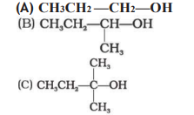
(a) (A) > (B) > (C)
(b) (C) > (B) > (A)
(c)(B)>(A)>(C)
(d)(A)>(C) >(B)
Ans. (b)
2. Aryl halides cannot be prepared by the reaction of aryl alcohols with PCl3, PCl5 or SOCl2 because:
(a) phenols are highly stable compounds.
(b) carbon-oxygen bond in phenols has a partial double bond character.
(c) carbon-oxygen bond is highly polar
(d) all of these
Ans. (b)
3. Molecules whose mirror image is non-superimposable over them are known as chiral. Which of the following molecules is chiral in nature?
(a) 2-Bromobutane
(b)1-Bromobutane
(c) 2-Bromopropane
(d) 2-Bromopropan-2-ol
Ans. (a)

4. Choose the most suitable classification for the shown compound?
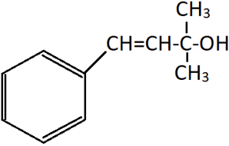
a) Secondary alcohol
b) Allylic alcohol
c) Dihydric alcohol
d) Benzylic alcohol
ANS. (b)
5. Identify X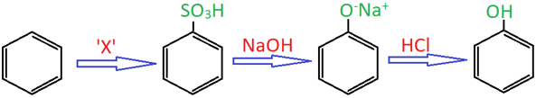
a) Oleum
b) Sulphuric acid
c) Nitrous acid
d) Sodium sulphate
ANS. (a)
6. Which of the following is incorrect regarding Kolbe’s reaction?
a) The final product is Salicylic acid
b) CO₂ acts as an electrophile
c) Acidification of phenol leads to formation of main product
d) Phenoxide ion undergoes electrophilic attack
ANS.( c)
7. Which of the following phenols is the most acidic?
a) o-Cresol b) m-Cresol
c) o-Nitrophenol
d) m-Nitrophenol
ANS. ( c)
*******************************

ALCOHOLS, PHENOLS AND ETHERS.

A) Both assertion and reason are correct statements, and reason is the correct explanation of the assertion.
B) Both assertion and reason are correct statements, but reason is not the correct explanation of the assertion.
C)Assertion is correct, but reason is wrong statement.
D)Assertion is wrong, but reason is correct statement.

1.Assertion: Phenols are more acidic than aliphatic alcohols.
Reason: The phenoxide ion is more resonance stabilized than alkoxide ion. (A)
2.Assertion: Tertiary alcohols gets converted into an alkene instead of a carbonyl Compounds in the presence of heated metallic copper.
Reason: Tertiary alcohols prefer to undergo dehydrogenation instead of dehydration in the presence of heated copper. (C)
3.Assertion: Ethers are non-polar when they are symmetrical.
Reason: Ethers have a bent structure. (D)
4.Assertion: n-Butanol has higher boiling point than 2-methyl propan-2-ol.
Reason: Branching increases the strength of Vander Waals forces. (C)
5.Assertion: It is not possible to prepare anisole from chlorobenzene through Williamson’s synthesis.
Reason: The C-Cl bond in chlorobenzene shows partial double bond character due to resonance. (A)

6.Assertion: Nitro phenol has lower pKa value than phenol.
Reason: The electron withdrawing nature of the nitro group further stabilizes the phenoxide ion formed. (A)
7.Assertion: Anisole reacts with HI to give phenol and chloromethane.
Reason: The –OCH3 group in anisole enriches the electron density in the ring through Resonance. (B)
8.Assertion: It is not possible to purify alcohol beyond 95% purity by simple distillation.
Reason: The intermolecular hydrogen bond in alcohol increases the boiling point of 95% alcohol. (C)
9.Assertion: Ethanol can be distinguished from methanol using iodoform test.
Reason: Ethanol has a methyl group attached to a carbon containing hydroxyl groups. (A)
10.Assertion: Methanol is called wood spirit.
Reason: Methanol can be prepared by the destructive distillation of fresh wood. (A)

***************************

Alcohos, Phenols, Ethers
CBQs
I) Read the following passage and answer the following questions
Although chlorobenzene is inert to nucleophilic substitution, however it gives quantitative yield of phenol when heated with aq. NaOH at high temperature and under high pressure. As far as electrophilic substitution in phenol is concerned the - OH group is an activating group, hence, its presence enhances the electrophilic substitution at o- and p-positions.
- Phenol undergoes electrophilic substitution more readily than benzene. Explain. (1)
- Phenol on treatment with excess of conc. HNO₃ gives ____________ (1)
- Why drastic reaction conditions are used in the conversion of chlorobenzene into phenol? (2)
OR
Write the equation showing preparation of Salicylaldehyde from Phenol. (2)

II)Read the passage given below and answer the following questions:
Both alcohols and phenols are acidic in nature, but phenols are more acidic than alcohols. Acidic strength of alcohols mainly depends upon the inductive effect. Acidic strength of phenols depends upon a combination of both inductive effect and resonance effects of the substituent and its position on the benzene ring. Electron withdrawing groups increases the acidic strength of phenols whereas electron donating groups decreases the acidic strength of phenols. Phenol is a weaker acid than carboxylic acid.
- Phenols are highly acidic as compare to alcohols. Explain (1)
- Why are phenols less acidic than carboxylic acid. Explain (1)
- Draw the resonance structures of phenoxide ion. (2)
OR
Arrange in increasing order of pKa values.
C₆H₅OH, C₆H₅CH₃, C₆H₅NO₂. Also give reason.

ANSWERS
I i)– OH group is electron releasing group. Due to + R effect, electron density on benzene increases.
ii)Mixture of Ortho, Para as well as meta nitrophenols.
iii)+R effect of Cl- group results in partial double bond character of the C- Cl bond.
OR
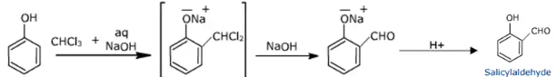
II
i)Phenoxide ion is resonance stabilized
ii)Carboxylate ion resonance structures are more stable than phenoxide ion resonance structures as negative charge is on the more electronegative oxygen atom in carboxylate ion whereas in phenol, it is on less electronegative carbon atoms.
iii)
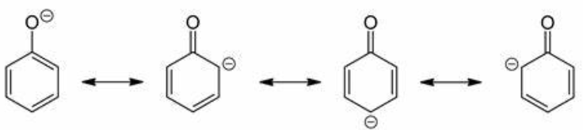
OR
C₆H₅NO₂ < C₆H₅OH < C₆H₅CH₃
Reason- - CH₃ group is electron releasing, - NO2 group is electron withdrawing.
Electron withdrawing group reduces the electron density on oxygen atom , thereby facilitating release of proton from – OH group.
III)Read the passage given below and answer the following questions:
A compound (X) containing C, H and O is unreactive towards sodium. It also does not react with Schiff’s reagent. On refluxing with an excess of hydroiodic acid, (X) yields only one organic product (Y). On hydrolysis, (Y) yields a new compound (Z) which can be converted into (Y) by reaction with red phosphorous and iodine. The compound (Z) on oxidation with potassium permanganate gives a carboxylic acid. The equivalent weight of this acid is 60.
(i) What is the compound (X)? (1)
Ans. ether
ii) The IUPAC name of the acid formed is_________________ (1)
Ans. ethanoic acid
iii) Compound (Y) is________________(1) Ans. ethyl iodide
compound (Z) is____________
Ans. ethanol
(iv) Compound (X) on treatment with excess of Cl₂ in presence of light gives_______________
(1)
Ans.perchlorodiethyl ether
1 | For the pair phenol and cyclohexanol. Answer the following: - (a) Why phenol more acidic than cyclohexanol? (b) Give one chemical test to distinguish between the two. | 2
Ans | a) Phenol is more acidic than cyclohexanol because the conjugate base of phenol i.e. phenoxide is more stable than conjugate base of cyclo- hexanol due to resonance. b) Phenol gives violet colour with neutral FeCl3 solution due to formation of Fe[Co(C6H5)6]complex.
2 | Two compound (A) and (B) have same molecular formula C4H10O. Both reacts with Na metal liberate H2 gas. Compound (A) gives yellow ppt. When reacts with I2 in NaOH but compound (B) does not respond to I2 in NaOH. Identify (A) and (B) | 2
Ans | (A) and (B) are Alcohols as they reacts with Na metal to give H2 gas.  (A)Butan-2-ol  ( B )2- methyl propan-2-ol
3 | In Kolbe’s reaction, instead of phenol, phenoxide ion is treated with carbon dioxide. Why? | 2
Ans | Phenoxide ion is more activating than phenol towards electrophilic substitution reaction. Hence, it undergoes electrophilic substitution with carbon dioxide, a weak electrophile.
4 | An organic compound (A) having molecular formula C6H6O gives a characteristic colour with aqueous FeCl3 solution. (A) on treatment with NaOH gives (B), which on treatment with CO2 and further acidification gives a compound (C). Identify A,B and C and Write the Chemical reactions involved.
Ans | 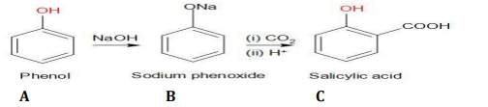
5 | Account for the following: -  (a) Alcohols are more soluble in water than the hydrocarbon of comparable molecular masses.  (b) Phenol doesn’t react with NaHCO3 whereas carboxylic acid reacts.  (c) Sodium metal can be used for drying Di ethyl ether but not ethyl alcohol.  (d) 2, 4, 6-trinitrophenol gives sodium bicarbonate test.  (e) Ortho nitro phenol is more volatile than para nitro phenol | 5
Ans | -(a)Alcohols have hydrogen bonding whereas hydrocarbons have weak van der Waal‘s force of attraction.  (b) Phenol is less acidic than carbonic acid whereas carboxylic acid is more acidic than carbonic acid.  (c) Sodium metal does not react with ether whereas it reacts with alcohol.  (d) 2, 4, 6-trinitrophenol is a stronger acid due to the presence of three nitro groups showing electron-withdrawing effect.  (e)Ortho nitro phenol has intramolecular hydrogen bonding and so molecules are less associated with each other whereas para nitro phenol has intermolecular hydrogen bonding.
********************************

CHAPTER-8. Aldehydes, Ketones and Carboxylic Acids
MCQs
1. Aldehydes and ketones are distinguished by using
(a) Tollen’s reagent
(b) Lucas’s reagent
(c) Borshe reagent
(d) all of these
2. Carbonyl compounds undergo nucleophilic addition because of
(a) More stable anion with negative charge on oxygen and less stable carbocation
(b) Electrometric effect
(c) Electronegativity difference of carbon and oxygen atoms
(d) None of these
3. Clemmensen reduction is carried with
(a) LiAlH4 in ether
(b) Zn-Hg and HCl
(c) H2 in the presence of Pd
(d) NH2NH2/glycol and KOH
4. The addition of HCN to carbonyl compounds is an example of
(a) Electrophilic addition
(b) Nucleophilic addition
(c) Nucleophilic substitution
(d) Electrophilic substitution
5. Cyanohydrin of which of the following will yield lactic acid?
(a) HCHO
(b) CH3COCH3
(c) CH3CH2CHO
(d) CH3CHO
6. If formaldehyde and KOH are heated, then we get
(a) Methyl alcohol
(b) Acetylene
(c) Methane
(d) Ethyl formate
7. Which of the following will not give iodoform test?
(a) Ethanol
(b) Ethanal
(c) Pentan-3-one
(d) Pentan-2-one
8. Oxidation of toluene to benzaldehyde by the use of chromyl chloride is called
(a) Wurtz reaction
(b) Fittig reaction
(c) Etard’s reaction
(d) Rosenmund’s reaction
Answers = 1. (a) 2. (a) 3. (b) 4. (b) 5. (d) 6. (a) 7. (c) 8. (c)

ALDEHYDES, KETONES AND ACIDS

A) Both assertion and reason are correct statements, and reason is the correct explanation of the assertion.
B )Both assertion and reason are correct statements, but reason is not the correct explanation of the assertion.
C)Assertion is correct, but reason is wrong statement.
D)Assertion is wrong, but reason is correct statement.

1.Assertion: Carboxylic acids do not show properties of carbonyl group.
Reason: The -C=O in carboxyl group is in resonance with the -OH group. (A)
2.Assertion: Chloro acetic acid has higher pKa value than Acetic acid..
Reason: The – I effect of Cl further stabilises the carboxylate anion formed by the loss of the proton. (D)
3.Assertion: Benzaldehyde resists nucleophilic addition in comparison with Ethanal
Reason: The Phenyl group in benzaldehyde is too bulky and therefore prevents attack of Nucleophile. (C)
4.Assertion: Aldehydes undergo aldol condensation only if it has α-hydrogen.
Reason: The α-hydrogen in aldehydes are acidic in nature because the anion formed by the loss of the α-hydrogen is resonance stabilized. (A)
5.Assertion: Ketones have low boiling point compared to corresponding alcohols.
Reason: Ketones from intermolecular hydrogen bonding with alcohols. (B)
6.Assertion: Carboxylic acids have greater boiling point than alcohols.
Reason: Carboxylic acids have the ability to form dimers in solution. (B)
7.Assertion: Dry HCl is a must for reaction of aldehyde with alcohol to form hemiacetal.
Reason: HCl protonates the carbonyl oxygen increasing the electrophilicity of the carbonyl carbon. (A)
8.Assertion: Even though there are two NH2 groups in semicarbazide, only one reacts with carbonyl compounds
Reason: Semicarbazide has two NH2 groups out of which one is in resonance with the
carbonyl group. (A)
9.Assertion: Benzoic acid does not undergo Freidel Crafts reaction.
Reason: The carboxyl group in benzoic acid donates electrons into the ring through resonance. (C)
10.Assertion: Ketones are more reactive thatn aldehydes towards nucleophilic addition.
Reason: The alkyl groups in ketone increases the electron density on the carbonyl carbon through +I effect. (D)
ALDEHYDES , KETONES & CARBOXYLIC ACIDS
CASE BASED QUESTIONS
(a) The aldehydes and ketones undergo nucleophilic addition reactions. A nucleophile attacks the electrophilic carbon atom of the polar carbonyl group from a direction approximately perpendicular to the plane of sp 2 hybridised orbitals of carbonyl carbon. The hybridisation of carbon changes from
sp ² to sp ³in this process, and a tetrahedral alkoxide intermediate is produced. These intermediate captures a proton
from the reaction medium to give the electrically neutral product. The net result is addition of Nu– and H+ across the carbon oxygen double bond.
1. Though carboxylic acid contains C=O group but it does not give nucleophilic addition reactions, why?
2. How will you convert ethanal to lactic acid?
3. Arrange the following compounds in their increasing order of reactivity towards nucleophilic addition reactions- C6H5CHO, HCHO, CH3CHO, CH3COCH3
4. Complete the following reactions-
(a) CH3CHO + C2H5OH →
(b) CH3CHO+ NaOH (Dil) →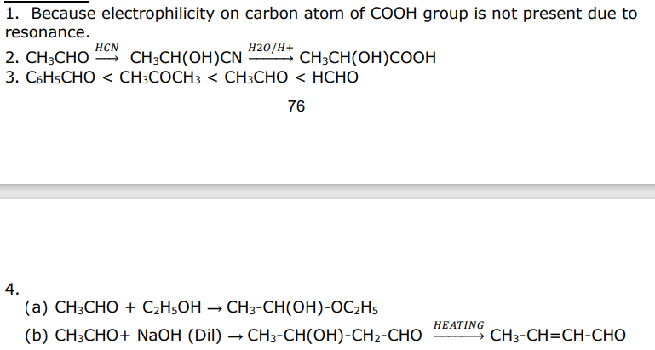

(b) Aliphatic carboxylic acids upto nine carbon atoms are colourless liquids at room temperature with unpleasant odours. The higher acids are wax like solids and are practically odourless due to their low volatility. Carboxylic acids are higher boiling liquids than aldehydes, ketones and even alcohols of comparable molecular masses. Carboxylic acids are weaker than mineral acids, but they are stronger acids than alcohols and many simple phenols (pKa is ~16 for ethanol and 10 for phenol). In fact, carboxylic acids are amongst the most acidic organic compounds you have studied so far.
1. Ethanoic acid forms dimer in vapour state, justify.
2. Why carboxylic acids have higher boiling points than that of aldehydes & ketones of comparable molecular masses, why?
3. Though phenoxide ion has more number of resonating structures than carboxylate ion but phenol is weaker acid than carboxylic acids, why?
4. Arrange the following compounds in their increasing order of pKa- (i) HCOOH, C6H5COOH, CH3COOH (ii) BrCH2COOH, ClCH2COOH , FCH2COOH
ANSWER
1. Due to formation of intermolecular hydrogen bond.
2. Due to formation of intermolecular hydrogen bond.
3. In carboxylate ion charge separation is among same atoms i.e. oxygen atoms whereas in phenoxide ion it is among different atoms i.e. oxygen and carbon atoms hence carboxylate ion is more stable and carboxylic acids are stronger acids.
4. (i) C6H5COOH> CH3COOH > HCOOH BrCH2COOH >ClCH2COOH > FCH2COOH

4.A compounds C (molecular formula C2H4O2) reacts with Na metal to form a compound R and evolves a gas which burns with a pop sound. Compound C on treatment with an alcohol A in presence of acid forms a sweet-smelling compound S (molecular compounds C3H6O2). On addition of NaOH to C, it also gives R and water. S on treatment with NaOH solution gives back R and A. Identify C, R, A, S and write down the reactions involved. (1x4=4)

Solution
C- Ethanoic acid
R- Sodium salt of Ethanoic acid and gas evolved is Hydrogen
A- Methanol
S- Ester
(a) 2CH3COOH+2Na→2CH3COONa+H2O
(b) CH3COOH+CH3OHCH3COOCH3+H2O
(c) CH3COOH+NaOH→CH3COONa+H2O
(d) CH3COOCH3+NaOH→CH3COONa+CH3OH

***************************************

1 | Although phenoxide ion has more number of resonating structures than carboxylate ion, carboxylic acid is a stronger acid than phenol. Why? | 2
Ans | The electronic charge in the carboxylate ion is more dispersed in comparison to phenate ion. Carboxylate ion is more stable as compared to phenate ion. The release of H+ ion is easier from carboxylic acid. It behaves as a stronger acid than phenol
2 | How will you prepare the following compounds from benzene? You may use any inorganic reagent and any organic reagent having not more than one carbon atom. (i) p-nitrobenzoic acid (ii) p-nitrobenzaldehyde | 2
 | 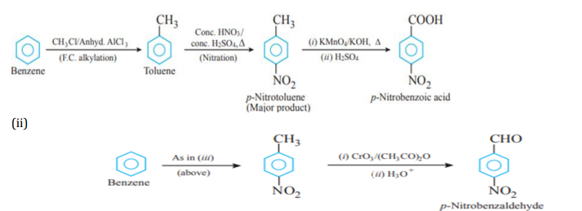
3 | Give reasons:  (i) Alpha hydrogen of aldehydes and ketones are acidic in nature.  (ii) Propanone is less reactive than ethanal towards addition of HCN.  (iii) Benzoic acid does not give Friedel-Crafts reaction. | 3
Ans. | (i) due to the strong withdrawing effect of the carbonyl group and resonance stabilisation of the conjugate base.  (ii) the presence of two methyl groups in propanone hinders more the approach of nucleophile to carbonyl carbon than in ethanal having one methyl group and two methyl groups reduce the positivity of the carbonyl carbon more effectively in propanone than in ethanal.  (iii) Carboxyl group is strongly deactivated and catalyst AlCl3 is a lewis acid that gets bonded to the carboxyl group strongly.
4 | (a) An organic compound ‘A’ having molecular formula C5H10O gives negative Tollens’ test, forms n-pentane on Clemmensen reduction but doesn’t give iodoform test. Identify ‘A’ and give all the reactions involved.  (b) Carry out the following conversions:  (i) Propanoic acid to 2-Bromopropanoic acid  (ii) Benzoyl chloride to benzaldehyde  (c) How will you distinguish between benzaldehyde and acetaldehyde? | 5
 | 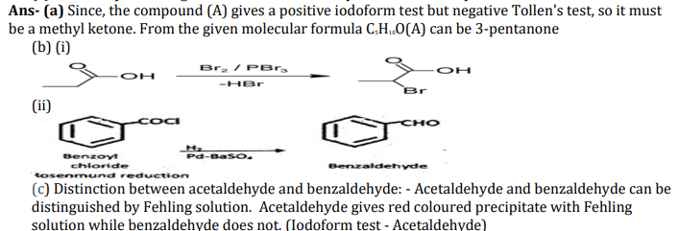
5 | 3 (a) Carry out the following conversions:  (i) P-nitrotoluene to 2-bromobenzoic acid  (ii) Propanoic acid to acetic acid  (b) An alkene with molecular formula C5H10 on ozonolysis gives a mixture of two compounds, B and C. Compound B gives positive Fehling test and also reacts with iodine and NaOH solution. Compound C does not give Fehling solution test but forms iodoform. Identify the compounds A, B and C
Ans | 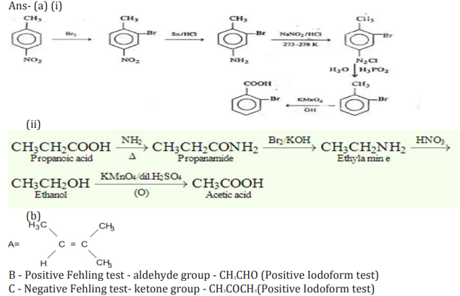

********************

CHAPTER-9.AMINES
MCQs

Q.1 Acetamide is treated with the following reagents separately. Which one of these would yield methyl amine?
(A)PCl₅
(B)NaOH/Br₂
(C)Sodalime
(D)Hot conc. H₂SO₄
_{ANS. (B)}
Q.2 Method by which Aniline cannot be prepared is:
(A)reduction of nitrobenzene with H₂ /Pd in ethanol
(B)potassium salt of phthalimide treated with chlorobenzene followed by hydrolysis with aqueous NaOH solution
(C)hydrolysis of phenylisocyanide with acidic solution
(D)degradation of benzamide with bromine in alkaline solution
ANS.(B)
Q.3Which of the following reactions is appropriate for converting acetamide to methanamine ?
(A)Hoffmarnn hypobromamide reaction
(B)Stephens reaction
(C)Gabriels phthalimide synthesis
(D)Carbylamine reaction
ANS. (A)
Q.4Basic nature of amine in aqueous medium can be explained by:
(A)Inductive effect
(B)Solvation effect
(C)Steric hinderance
(D)All of these
ANS.(D)

Q5.Which of following is correct regarding basic nature:
(A)R-NH₂ > R₂NH > R₃N (Gaseous phase)
(B)CH₃NH₂(CH₃)₂NH > (CH₃)₃N(Aqueous solutions)
(C)(C₂H₅)₂NH > (C₂H₅)₃N > C₂H₅-NH₂ > NH₃ (Aqueous solutions)
(D)(C₂H₅)₂NH > PhNH₂ > Ph-NH-CH₃(Aqueous solution)
ANS. (C)
Q.6Which of following can be used to distinguish primary, secondary and tertiary amine?
(A)Carbyl amine reaction
(B)Reaction with Nitrous acid
(C)Reaction with Hinsberg’s reagent
(D)Both B & C
ANS. (C)
Q.7 Ethanamine can be obtained if the following compound is heated with [KOH + Br₂ ]
(A) Ethanamide
(B) Methanamide
(C) Propionamide
(D) All the above
ANS. (C)
Q.8 C₂H₅-NH₂ cannot be prepared by the reduction of
(A) C₂H₅-NO₂
(B) C₂H₅-NC
(C) CH₃-CN
(D) CH₃-CH=NOH
ANS. (D)
Q. 9 Gabriel phthalimide reaction is used in the synthesis of
(A)Primary aromatic amines
(B)Secondary amines
(C)Primary aliphatic amines
(D)Tertiary amines
ANS.(C)

Q.10 Solubility of ethylamine in water is due to
(A)Low molecular weight
(B)Ethyl group is present in ethyl alcohol
(C)Formation of H-bonding with water
(D)Being a derivative of ammonia
ANS. (C)
********************************

AMINES

A) Both assertion and reason are correct statements, and reason is the correct explanation of the assertion.
B )Both assertion and reason are correct statements, but reason is not the correct explanation of the assertion.
C)Assertion is correct, but reason is wrong statement.
D)Assertion is wrong, but reason is correct statement.

1.Assertion: Hoffmann’s ammonolysis can be used to prepare pure primary amines.
Reason: Ammonolysis of haloalkanes lead to multiple substitution of alkyl groups on nitrogen. (D)
2.Assertion: Aniline is less basic than ammonia.
Reason: The lone pair on nitrogen in aniline is donated into the ring through resonance. (A)
3.Assertion: Tertiary amines have lower boiling point than corresponding secondary and primary amines. (C)
Reason: Tertiary amines have higher intermolecular hydrogen bonding.
4.Assertion: Tertiary amines do not undergo acylation reaction.
Reason: There are no replaceable hydrogens on the nitrogen in tertiary amines. (A)
5..Assertion. Carbyl amine reaction cannot be used as a test to distinguish between aniline and methanamine.
Reason: Both aniline and methanamine are primary amines. (A)
6.Assertion: Diazotisation of aniline should be done near 0ºC.
Reason: Aniline is less reactive towards sodium nitrite at normal temperatures. (C)
7.Assertion: Aniline forms significant amount of meta derivative on nitration with con.HNO3 and Con. H2SO4
Reason: The ortho and para positions in aniline is electron rich due to the activating nature
of -NH2 group. (B)
8.Assertion: Aniline does not undergo Freidel Crafts reaction.
Reason: Being a Lewis base, aniline reacts with anh.AlCl3 to form salt. (A)
9.Assertion: Aniline cannot be prepared by Gabriel phthalimide synthesis.
Reason: Phthalimide does not react with chlorobenzene due to large size of phenyl group.
(C)
10.Assertion: Acetylation of aniline enhances the tendency to undergo electrophilic substitution.
Reason: Acetylation reduces the activation of the benzene ring by the NH2 group since it can undergo resonance with both benzene ring and Acetyl group. (D)
1 | How would you account for the following:  (a) Electrophilic substitution in case of aromatic amines takes place more readily than benzene.  (b) Ethanamide is a weaker base than ethanamine. | 2
 | 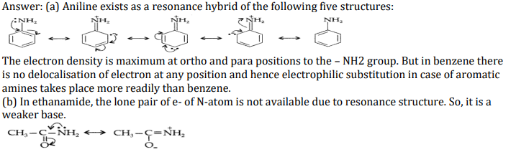
2 | How will you convert the following:  (a) Ethanoic acid to methanamine  (b) Benzene diazonium chloride to phenol | 2
 | 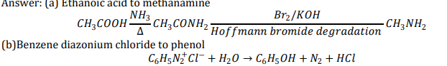
3 | Mr. Krishna, a chemistry teacher gave his class students a sample of an amine “P” having molecular formula C4H11N to test, identify and write the reaction. The students observed that it reacts with Hinsberg’s reagent to form an alkali soluble product. A student Ranu wrote the reaction as follows  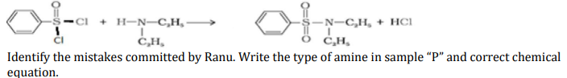 | 5
Ans | 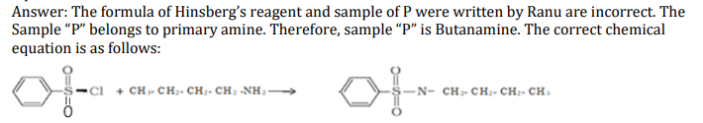
4 | - An aromatic compound A of molecular formula C7H7ON undergoes a series of reactions as shown below. Write the structures of A, B, C, D and E in the following reactions:  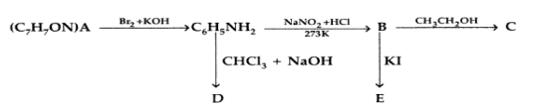 | 5
 | 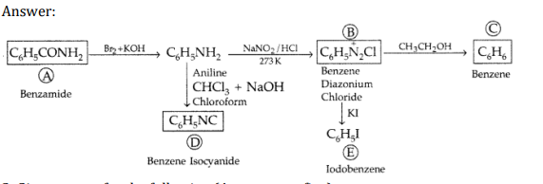
5 | Give reasons for the following (Attempt any five):  (a) Aniline does not undergo Friedal-Crafts reaction.  (b) (CH3)2NH is more basic than (CH3)3N in an aqueous solution.  (c) Primary amines have higher boiling point than tertiary amines.  (d) CH3NH2 is more basic than C6H5NH2.  (e) Although —NH2 is o-p directing group, yet aniline on nitration gives a significant amount of m-nitroaniline. (f) pKb of aniline is more than that of methylamine (g) Ethylamine is soluble in water whereas aniline is not. | 5
Ans. | (a) Aniline being a Lewis base reacts with Lewis acid AlCl3 to form a salt. As a result, N of aniline acquires positive charge and hence it acts as a strong deactivating group for electrophilic substitution reaction. Consequently, aniline does not undergo Freidel Crafts reaction.  (b) In (CH3)3N there is maximum steric hindrance and least solvation but in (CH3)2NH the solvation is more and the steric hindrance is less than in (CH3)3NH; although + I effect is less, since there are two methyl groups; di-methyl amine is still a stronger base than tri-methyl.  (c) Due to presence of two H-atoms on N-atom of primary amines, they undergo extensive intermolecular H-bonding while tertiary amines due to the absence of a H-atom on the N-atom, do not undergo H- bonding. As a result, primary amines have higher boiling points than 3° amines.  (d)CH3NH2 is more basic than aniline due to availability of lone pair of electrons for donation while in aniline lone pair of electrons on the nitrogen atom is delocalised over benzene ring and thus unavailable for donation.  (e) Because of nitration in an acidic medium, aniline gets protonated to give anilinium ion which is indirecting. (f) In aniline, the lone pair of electrons on the N-atom is delocalised over the benzene ring. As a result, electron density on the nitrogen atom decreases. Whereas in CH3NH2, + I-effect of -CH3 group increases the electron density on the N-atom. Therefore, aniline is a weaker base than methylamine and hence its pKb value is higher than that of methylamine. (g) Ethylamine dissolves in water due to intermolecular H-bonding. However, in case of aniline, due to the large hydrophobic part, i.e., hydrocarbon part, the extent of H-bonding is very less therefore aniline is insoluble in water.

*************************************

CHAPTER-10. BIOMOLECULES
MCQs
1.The functional group which is found in amino acid is-(a)-COOH
( b) -NH2 ( c) -CH3
(d) both ( a) and ( b)
2.Which base is present in RNA but not in DNA?
(a) Uracil
( b) Cytosine
(c) Guanine
(d) Thymine
3. The anomeric carbon in D(+) glucose is –
(a) C-1 carbon
(b) C-2 carbon
(c) C-5 carbon
(d) C-6 carbon
4. Each polypeptide in protein has amino acids linked with each other in a specific sequence. This
sequence of amino acids is said to be-
(a) primary structure of proteins.
(b) secondary structure of proteins.
(c) tertiary structure of proteins.
(d) quaternary structure of proteins.
5.Which statement is incorrect about peptide bond?
(a) C-N bond length in proteins is longer than usual bond length of C-N bond.
(b) Spectroscopic analysis shows planar structure of -CO-NH- group
(c) C-N bond length in proteins is smaller than usual bond length of C-N bond
(d) None of the above
6. The reason for double helical structure of DNA is operation of-
(a) electrostatic attractions (b) dipole-dipole interaction
(c) van der Waal’s forces (d) hydrogen bonding
7.Which of the following factors is not responsible for the denaturation of proteins?
(a) Heat
(b) Charge
(c) PH change
(d) Organic solvents
8.Fructose contains functional group-
(a) Aldehyde
(b) Ketone
(c) Carboxylic acid
(d) primary amine
9. The letter ‘D’ in carbohydrates signifies-
(a) dextrorotatory
(b) configuration
(c) diamagnetic nature
(d) mode of synthesis
10.RNA and DNA are chiral molecules. Their chirality is due to :
(a) Chiral bases
(b) Chiral phosphate ester units
(c) D-sugar component
(d) L-sugar component.
Ans- 1 (d) 2 (a) 3 (a) 4 (a) 5 (a) 6 (d) 7 (b) 8 (b) 9(b) 10 (c)

**********************************
BIOMOLECULES
A) Both assertion and reason are correct statements, and reason is the correct explanation of the assertion.
B )Both assertion and reason are correct statements, but reason is not the correct explanation of the assertion.
C)Assertion is correct, but reason is wrong statement.
D)Assertion is wrong, but reason is correct statement.

1.Assertion: The hydrolysis of sucrose to glucose and fructose is called inversion of cane sugar.
Reason: The dextro rotatory sucrose forms a laevo rotatory mixture on hydrolysis. (A)
2.Assertion: Glycine is not optically active.
Reason: There is no asymmetrical carbon in glycine to make it chiral. (A)
3.Assertion: Vitamin C has to be continuously supplied through diet.
Reason: Vitamin C is a water-soluble vitamin. (A)
4.Assertion: Amino acids in a protein remain intact even when it is denatured.
Reason: The primary structure of protein is broken to give individual amino acids on denaturation. (C)
5.Assertion. Despite having aldehyde group, aldehyde does not show schiff’s test.
Reason: The aldehyde group in glucose is used to from the ring structure of glucose. (A)
6.Assertion: Non-essential amino acids are not necessary for protein synthesis.
Reason: Non-essential amino acids are produced in the human body. (D)
7.Assertion: Naturally occurring amino acids have L-configuration.
Reason: The structure of naturally occurring amino acids have similarity with L-glyceraldehyde. (B)
8.Assertion: Increased level of glucagon will improve the glucose content in blood.
Reason: Glucagon and insulin regulates the sugar levels in blood. (B)
9.Assertion: Less intake of iodine in diet leads to enlargement of thyroid gland
Reason: iodine deficiency leads to hyperthyroidism. (C)
10.Assertion: The bond between adenine and thymine is stronger than the bond between Cytosine and guanine.
Reason: Cytosine and guanine have a triple hydrogen bond while adenine and thymine have a double hydrogen bond. (D)
CASE BASED Qs

QI) Protein primary structure is the linear sequence of amino acids in a peptide or protein. In contrast, Secondary structure refers to regular, recurring arrangements in the space of adjacent amino acid residues in a polypeptide chain. It is maintained by hydrogen bonds between amide hydrogens and carbonyl oxygens of the peptide back bone. The major secondary structures are α-helix and β- pleated structures. The tertiary structure of protein represents overall folding of secondary structure. Two major type molecular shapes which are found naturally are fibrous and globular. Protein found in a biological system with a unique three-dimensional structure and biological activity is called a native protein. When a protein in its native form, is subjected to physical changes like change in temperature or chemical changes like change in pH, the hydrogen bonds are disturbed. Due to this, globules unfold and helix get uncoiled and protein loses its biological activity. This is called denaturation of protein. The denaturation causes change in secondary and tertiary structures but primary structures remain intact. Examples of denaturation of protein are coagulation of egg white on boiling, curding of milk, formation of cheese when an acid is added to milk.
Answer following questions:
(a) What type of bonding helps in stabilizing the α-helix structure of proteins? (1)
(b) Where does the water present in egg goes after boiling the egg? (1)
(c) Give two differences between globular and fibrous protein. (2)
or
(c) What is meant by a peptide linkage? Explain with one example.
Ans
(a) Hydrogen bonding
(b) When egg is boiled, the protein first undergoes denaturation and then coagulation. The water present in the egg gets absorbed in the coagulated proteins through H – bonding.
(c) Any two correct differences.
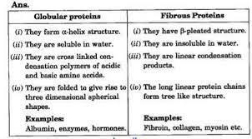
or
The CONH bond in proteins is called peptide bond.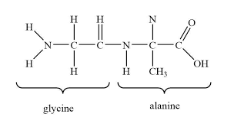

QII) Strengthening the Foundation: Chargaff Formulates His "Rules"
Many people believe that James Watson and Francis Crick discovered DNA in the 1950s. In reality, this is not the case. Rather, DNA was first identified in the late 1860s by Swiss chemist Friedrich Miescher. Then, in the decades following Miescher's discovery, other scientists--notably, Phoebus Levene and Erwin Chargaff--carried out a series of research efforts that revealed additional details about the DNA molecule, including its primary chemical components and the ways in which they joined with one another. Without the scientific foundation provided by these pioneers, Watson and Crick may never have reached their groundbreaking conclusion of 1953: that the DNA molecule exists in the form of a three-dimensional double helix.
Chargaff, an Austrian biochemist, as his first step in this DNA research, set out to see whether there were any differences in DNA among different species. After developing a new paper chromatography method for separating and identifying small amounts of organic material, Chargaff reached two major conclusions:
(i) the nucleotide composition of DNA varies among species.
(ii) Almost all DNA, no matter what organism or tissue type it comes from maintains certain properties, even as its composition varies. In particular, the amount of adenine (A) is similar to the amount of thymine (T), and the amount of guanine (G) approximates the amount of cytosine (C). In other words, the total amount of purines (A + G) and the total amount of pyrimidines (C + T) are usually nearly equal. This conclusion is now known as "Chargaff's rule."
Chargaff’s rule is not obeyed in some viruses. These either have single- stranded DNA or RNA as their genetic material.
Answer the following questions:
a. A segment of DNA has 100 adenine and 150 cytosine bases. What is the
total number of nucleotides present in this segment of DNA? (1)
b. A sample of hair and blood was found at two sites. Scientists claim that the
samples belong to same species. How did the scientists arrive at this conclusion? (1)
c. The sample of a virus was tested and it was found to contain 20% adenine,
20% thymine, 20 % guanine and the rest cytosine. Is the genetic material
of this virus (a) DNA- double helix (b) DNA-single helix (c) RNA? What do
you infer from this data? (2)
OR
How can Chargaff’s rule be used to infer that the genetic material of an
organism is double- helix or single- helix?
Ans.
1. a. A = 100 so T = 100
C=150 so G = 150
Total nucleotides = 100+100+150+150 =500 (1)
b. They studied the nucleotide composition of DNA. It was the same so they
concluded that the samples belong to same species. (1)
c. A = T = 20%
But G is not equal to C so double helix is ruled out. (1/2)
The bases pairs are ATGC and not AUGC so it is not RNA (1/2)
The virus is a single helix DNA virus (1)
OR
According to Charagraff rule, all double helix DNA will have the same amount of
A and T as well as C will be same amount as G. If this is not the case then the
helix is single stranded.

QIV) Life is possible due to coordination of various chemical reactions take place in living organisms. All biochemical reactions in our body take place at
37 °C and these reactions are slow. These reactions occur with the help of certain biological catalysts called enzymes. Almost all enzymes are globular proteins. These are highly specific in their action, work at specific pH.
(i) Which enzyme converts starch to glucose? ( 1)
(ii) Which enzyme dissolves blood clots?(1)
(iii) Why are enzymes specific in their actions?(1)
Ans :
(i) Diastase converts starch into maltose. Maltase converts maltose into glucose.
(ii) Streptokinase dissolves blood clots.
(iii) It is because a particular substrate can bind with active sites of enzymes.

QV) Glucose occurs freely in nature as well as in combined form. It is present in sweet fruits and honey. Ripe grapes also contain glucose in large amount. Glucon-D is instant source of energy. Starch gets hydrolysed into glucose in our body. Glucose is stored in the form of glycogen.
(i) What is meant by D in Glucon-D? (1)
(ii) What will happen if we have high amount of glucose in our blood? (1)
(iii) How will you test glucose in urine of diabetic patients? Which property of glucose is used? (1)
(iv) How often people suffering from type I diabetes, should perform test for diabetes? How will it help? (1)
Ans :
(i) It contains dextro-rotatory glucose commonly called dextrose.
(ii) It will cause diabetes.
(iii) Add Fehling’s’ solution A and B or Benedict’s reagent in equal amounts. Heat the test tube on water bath. If brick red precipitate is formed, it shows presence of glucose. It is based on reducing property of glucose.
(iv) These people should perform this test regularly so that they can adjust the dose of insulin which they take regularly.
******************************

1 | What happens when D-glucose is treated with the following reagents? (any two) (i) Hydroxylamine (ii) Bromine water (iii) Acetic anhydride | 2
Ans | (i) oxime (ii)Gluconic acid (iii) Glucose pentaacetate
2 | Write one difference between α-helix and β-pleated sheet structures of protein | 2
Ans. | In the α-helix structure of proteins, the polypeptide chains are stabilised by intramolecular hydrogen bonding whereas β-pealed sheet structure of proteins is stabilised by intermolecular hydrogen bonding.
3 | Write down the structures and names of the products formed when D-glucose is treated with (i) Bromine water (ii) Hydrogen Iodide (Prolonged heating). (iii) HNO3 | 3
Ans. | 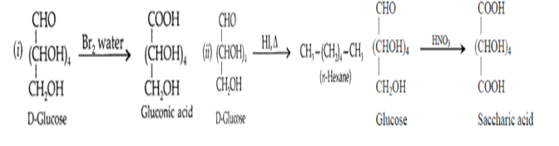
4 | (a) Give one example each for fibrous protein and globular protein.  (b) Amino acids may be acidic, alkaline or neutral. How does this happen?  (c) Name one oil soluble vitamin which is a powerful antioxidant and give its one natural source. | 5
Ans | (a) Globular protein: All enzymes and hormones like insulin. Fibrous protein: Keratin in skin.  (b) Amino acids can be broadly classified into the classes depending on the number of —NH2 group and — COOH group. Acidic amino acids: Those amino acids such as aspartic acid, asparagine and glutamic acid which contain two -COOH groups and one -NH2 group are called acidic amino acids. Alkaline or Basic amino acids: Those amino acids such as lysine, arginine and histidine which contain two -NH2 groups and one -COOH group, are called basic amino acids. Neutral amino acids: Those amino acids such as glycine, alanine, valine etc. which contain one -NH2 and one – COOH group, are called neutral amino acids.  (c) Oil soluble Vitamin: Vitamin D Natural source: Fish liver oil, butter, milk, eggs etc.

******************************

